
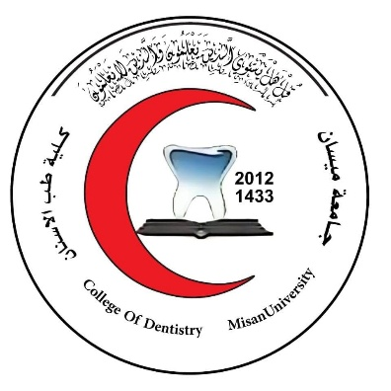
Republic of Iraq
Ministry of Higher Education
and Scientific Research
University of Misan
College of Dentistry

Title: The Role of the Oral Microbiome in The Development of Cancer: Systemic Review

A graduation project submitted to the College of Dentistry in partial fulfillment of the requirements for the degree of Bachelor of Dental Science.

Supervisor:
DVM, MSC, PhD, Immunologist
Ahmed Mohammed Alwan
Students:
Duaa Abdul Hussein Jabbar
Zainab Karim Kazim
Mohammed Abdul Karim Kazim

2025

الآية القرآنية

﷽


صدق الله العلي العظيم
) سورة يونس – الآية: 10(

Dedication
To those whose prayers were the secret behind my success,
To those who carried me on the shoulders of hope and opened the doors to my dreams,
To those who stayed up through the nights for me, enduring my exhaustion and mood swings..
To my mother, the embodiment of tenderness and warmth, whose love and patience knew no limits,
And to my father, the steadfast mountain I always leaned on, my greatest support in life.
To my brothers and sisters, who were both family and friends..
Those who shared my joy, soothed my sorrow, and stood by me when I needed a listening ear.
To my esteemed teachers, who offered their knowledge freely and served as beacons of light guiding my path,
And to my dear colleagues, who walked beside me on this journey of learning, diligence, and perseverance, leaving behind memories I will always cherish—
With all my gratitude and love, this work is dedicated to you.

Acknowledgments
Praise be to God, who has granted us the gift of reason to illuminate our path and, by His will and power, enabled us to complete this work in its present form. A sense of loyalty and gratitude compels us to extend our heartfelt thanks and appreciation to everyone who supported us whether through a word, a gesture, or an idea.
We would like to express our special gratitude to Dr. Ahmed Mohammed Alwan, whose excellent supervision and continuous support greatly enriched this research. Our sincere thanks also go to the esteemed faculty members of the College of Dentistry for their collaboration and encouragement who serve as beacons of knowledge and role models of academic dedication. Their guidance, constructive feedback, and unwavering scientific mentorship were instrumental in shaping this project to meet the standards we aspire to.
To my beloved family my greatest source of support and strength and to all those who believed in me and encouraged me along the way, I offer this humble effort as a token of my gratitude and respect.
Finally, I present this work to my esteemed College of Dentistry at the University of Misan, which has instilled in us the values of research, academic integrity, and responsibility. May this work serve as a modest contribution to its enduring academic legacy.

Certification of supervision
I hereby certify that the project entitled “The Role of the Oral Microbiome in the Development of Cancer” was conducted by fifth-year students under my supervision at the University of Misan, College of Dentistry, in partial fulfillment of the requirements for the degree of Bachelor of Science in Dentistry.
Supervisor name: lect. Dr. Ahmed Mohammed Alwan

Signature:
Date:

Defense Committee Certification
We, the undersigned, certify that we have read and evaluated the graduation project entitled:
“The Role of the Oral Microbiome in the Development of Cancer”
submitted by the fifth-year students of the College of Dentistry / University of Misan.
Having examined the content and findings of the project and observed the oral defense, we approve the project as fulfilling the partial requirements for the degree of Bachelor of Science in Dentistry.
Committee Members:
1. Dr.
Chairperson
Signature: _____________________ Date: _______________
2. Dr.
Member
Signature: _____________________ Date: _______________
3. Dr.
Member
Signature: _____________________ Date: _______________

Dean's Certification
I hereby certify that the graduation project entitled:
“The Role of the Oral Microbiome in the Development of Cancer”
submitted by fifth-year students of the College of Dentistry / University of Misan, has been reviewed and approved by the examining committee.
The project fulfills the academic requirements for the degree of Bachelor of Science in Dentistry.
Dean of the College of Dentistry
Prof. Dr. Ridha Alwan Hassan
Signature: _____________________
Date: _________________________

Abstract
Introduction
The oral microbiome, a dynamic ecosystem of microorganisms, plays a pivotal role in oral health and disease. Dysbiosis, chronic inflammation, and immune dysregulation are key contributors to oral squamous cell carcinoma (OSCC). This study explores microbial and inflammatory mechanisms driving OSCC, focusing on pathogens like HPV, Fusobacterium nucleatum, and cytokines such as IL-6 and IL-8.
Method
A systematic review of peer-reviewed studies (1970–2024) was conducted, analyzing microbial-host interactions, cytokine roles, and diagnostic strategies. Data were synthesized from clinical, molecular, and epidemiological research, including pathogen-specific mechanisms, cytokine profiling, and biomarker validation in saliva. Tables were constructed to categorize pathogens, associated conditions, and cytokine impacts. |
Result
HPV-16, Fusobacterium nucleatum, and Porphyromonas gingivalis were strongly linked to OSCC progression via immune evasion, chronic inflammation, and oncogenic signaling. Candida albicans and EBV promoted carcinogenesis through mutagenic metabolites and epithelial disruption. Salivary cytokines (IL-1β, IL-6, IL-8) emerged as biomarkers for early detection, with elevated levels correlating with tumor aggressiveness. Advanced imaging and saliva-based assays improved diagnostic precision, while microbial dysbiosis and IL-10 polymorphisms heightened cancer risk. |
Conclusion
Pathogens and cytokines synergistically drive OSCC by altering immune responses and fostering pro-tumorigenic microenvironments. Targeting microbial dysbiosis (e.g., probiotics, phage therapy) and cytokine signaling (e.g., IL-6/IL-8 inhibitors) may offer therapeutic benefits. Future research should prioritize longitudinal studies to map microbiome dynamics and integrate multi-omics approaches for personalized diagnostics. Early detection via non-invasive biomarkers and interdisciplinary collaborations are critical to improving clinical outcomes.
Keywords: Oral microbiome, OSCC, HPV, IL-6, inflammation.

List of abbreviations
No. | Abbreviation | Full Term
 | SCC | Squamous Cell Carcinoma
 | OSCC | Oral Squamous Cell Carcinoma
 | MMP | Matrix Metalloproteinase
 | MMP-9 | Matrix Metalloproteinase-9
 | IL-1β | Interleukin-1 beta
 | TNF-α | Tumor Necrosis Factor-alpha
 | PD-1 | Programmed Death-1
 | PD-L1 | Programmed Death-Ligand 1
 | HNSCC | Head and Neck Squamous Cell Carcinoma
 | HPV | Human Papillomavirus
 | ICIs | Immune Checkpoint Inhibitors
 | GCTs | Granular Cell Tumors
 | PENs | Palisaded Encapsulated Neuromas
 | HSV | Herpes Simplex Virus
 | VZV | Varicella-Zoster Virus
 | EBV | Epstein-Barr Virus
 | HPV | Human Papillomavirus
 | GAS | Group A Streptococcus
 | IL | Interleukin
 | TGF-β | Transforming Growth Factor-beta
 | LPS | Lipopolysaccharide
 | TLR | Toll-like Receptor
 | NF-κB | Nuclear Factor kappa-light-chain-enhancer of activated B cells
 | OSCC | Oral Squamous Cell Carcinoma (already in Chapter One, not repeated)
 | TME | Tumor Microenvironment
 | OPMDs | Oral Potentially Malignant Disorders
 | DIF | Direct Immunofluorescence
 | ROS | Reactive Oxygen Species
 | PBS | Phosphate Buffered Saline
 | EDTA | Ethylenediaminetetraacetic Acid
 | SCN⁻ | Thiocyanate
 | H₂O₂ | Hydrogen Peroxide
 | FFA | Free Fatty Acids
 | TFF3 | Trefoil Factor Family 3
 | LL-37 | Cathelicidin antimicrobial peptide
 | PRPs | Proline-Rich Proteins
 | MUC5B, MUC7 | Mucin family proteins
 | VEGF | Vascular Endothelial Growth Factor
 | JAK/STAT | Janus Kinase / Signal Transducer and Activator of Transcription
 | CASP | Critical Appraisal Skills Programme
 | PRISMA | Preferred Reporting Items for Systematic Reviews and Meta-Analyses
 | MeSH | Medical Subject Headings
 | Ref. | Reference (used to cite research studies)
 | TME | Tumor Microenvironment (already listed in Chapter Two, not repeated)
 | miR | microRNA
 | MMP | Matrix Metalloproteinase (already listed in Chapter One, not repeated)
 | G | Guanine (from IL-10 gene polymorphism notation A-1082G)
 | ECM | Extracellular Matrix
 | HA | Hyaluronic Acid
 | ICIs | Immune Checkpoint Inhibitors (already in Chapter One, not repeated)
 | DPT | Dental Panoramic Tomography (used synonymously with panoramic X-ray)
 | CT | Computed Tomography
 | MRI | Magnetic Resonance Imaging
 | DNA | Deoxyribonucleic Acid

Contents
الآية القرآنية I
Dedication II
Acknowledgments III
Certification of supervision IV
Defense Committee Certification V
Dean's Certification VI
Abstract VII
List of abbreviations VIII
Contents XI
List of tables XIV
List of figures XIV
1. Chapter one 1
1.1. Introduction 1
1.2. Goals 7
1.3. Questions 8
1.4. Objectives 8
2. Chapter Two: Method 11
2.1. Table Formation Methodology, and Rationale for Table Selection 11
2.1.1. Methodology for Table Construction 11
2.1.2. Reasons for Choosing This Table Format: - 11
2.2. Keywords 12
2.2.1. Core Keywords: - 12
2.2.2. Pathogen-Specific Keywords: - 13
2.2.3. Cytokine-Specific Keywords: 13
2.2.4. Mechanistic & Clinical Keywords: - 14
2.2.5. Anatomic & Diagnostic Keywords: 14
2.2.6. Search Combinations (Examples): 15
2.2.7. Factor-Specific Keywords: 15
3. Chapter Three: Results 17
3.1. Types of microorganisms that cause oral inflammation and their relationship with oral cancer 17
3.2. Types of microorganisms and their relationship with oral cancer: 21
22
3.3. Interleukins and Cancer 23
3.4. Cytokines in Oral Cancer and Infection: Roles, Research, and References: - 24
3.5. Oral Cancer-Related Factors and Their Impact on Dental Health: Mechanisms and Research Insights: - 26
4. Chapter Four: Discussion 29
4.1. Types of microorganisms that cause oral inflammation and their relationship with oral cancer: - 29
4.2. Types of microorganisms and their relationship with oral cancer: - 31
4.2.1. 4.2.1 Human Papillomavirus: 32
4.2.2. Fusobacterium nucleatum: 32
4.2.3. Candida albicans: 32
4.2.4. EBV: 32
4.2.5. Treponema denticola: 33
4.2.6. Porphyromonas gingivalis: 33
4.3. Cytokine Expression and Their Impact on Oral Squamous Cell Carcinoma Development 33
4.3.1. Interleukin-1β (IL-1β): 33
4.3.2. Interleukin-6 (IL-6): 33
4.3.3. Interleukin-8 (IL-8): 34
4.3.4. Interleukin-10 (IL-10): 34
4.4. Cytokines in Oral Cancer and Infection: Roles, Research, and References:- 34
4.4.1. Interleukin-6 (IL-6) plays a crucial role in the development of oral cancer through two main mechanisms: 34
4.4.2. Interleukin-8 (IL-8) plays a pivotal role in the progression of oral cancer and infection through two main mechanisms: 35
4.4.3. Tumor necrosis factor-alpha (TNF-α) exhibits a dual role in oral cancer and infection, as it: 35
4.4.4. Interleukin-1 beta (IL-1β) is a key factor in the progression of oral cancer and infection through the following mechanisms: 36
4.4.5. Interleukin-17 (IL-17) plays a critical role in oral cancer and infections through two primary mechanisms: 36
4.5. Oral Cancer-Related Factors and Their Impact on Dental Health: Mechanisms and Research Insights: - 36
4.5.1. Butyrate, a short-chain fatty acid produced by periodontal pathogens, exhibits dual roles in oral health: 37
4.5.2. The cytokines IL-6 and IL-8 play a significant role in exacerbating oral inflammation and periodontal disease: 37
4.5.3. Gingipains, proteolytic enzymes produced by Porphyromonas gingivalis, play a critical role in periodontal tissue destruction and oral pathology: 38
4.5.4. Lipopolysaccharide (LPS), a key virulence factor of Porphyromonas gingivalis, contributes to oral pathology through two critical mechanisms: 38
4.5.5. Hyaluronidase, an enzyme produced by periodontal pathogens, contributes to oral pathology through two key mechanisms: 39
4.5.6. Interleukin-1 beta (IL-1β) plays a central role in oral pathologies through two primary mechanisms: 39
4.5.7. Proteases, particularly gingipains produced by Porphyromonas gingivalis, drive oral pathology through two critical mechanisms: 40
5. Conclusion 41
6. Recommendations for Future Researchers: 41
5. Chapter five: References 43
الخلاصة 37

List of tables
Table ‎3-1: Types of microorganisms that cause oral inflammation and their relationship with oral cancer (63-71) 17
Table ‎3-2: Types of microorganisms and their relationship with oral cancer (72-77) 21
Table ‎3-3: Cytokine Expression and Their Impact on Oral Squamous Cell Carcinoma Development (78-81). 23
Table ‎3-4: Cytokines in Oral Cancer and Infection (82-86). 25
Table ‎3-5: Oral Cancer-Related Factors and Their Impact on Dental Health (87-93). 26

List of figures
Figure ‎0-1: appearance of mouth landmarks and tongue.
Figure 3-1: Infection Site Distribution In (Microorganisms And Oral Inflammation).
Figure ‎0-2: Distribution Of Inflammation Types.
Figure ‎0-3: Distribution of Research by Country.
Figure ‎0-4: Scientific Correlation: Microorganisms vs. Inflammation Sites (Oral Infections).
Figure ‎0-5: Distribution by Type of Cancer.
Figure 3-6: Distribution by Country of Researcher.
Figure ‎0-7: Scientific Correlation Map: Microorganisms vs. Infection Sites in Oral Cancer Studies.
Figure ‎0-8: Systematic Review Correlation: Cytokines vs. Inflammation Sites.
Figure ‎0-9: Systematic Review Correlation: Cytokines vs. Role in Oral Cancer/Infection.
Figure 3-10: Systematic Review Correlation: Secretions vs. Effects on Teeth.

تحذف اثناء الاستنساخ

Chapter one
Introduction

- Chapter one

Introduction
The oral cavity is an anatomical space formed by both hard and soft tissues, serving essential functions in speech, swallowing, and breathing (1). It is bordered at the front by the lips, on the sides by the cheeks, above by the hard palate, and below by the mucosa covering the tongue and the muscles connected to the inner part of the mandible, such as the geniohyoid, mylohyoid, and digastric muscles (2).
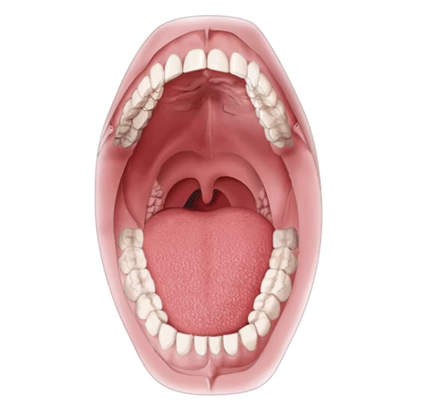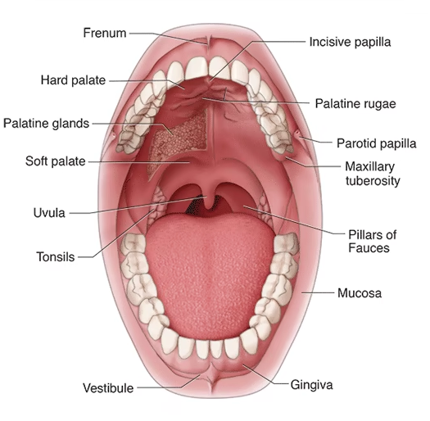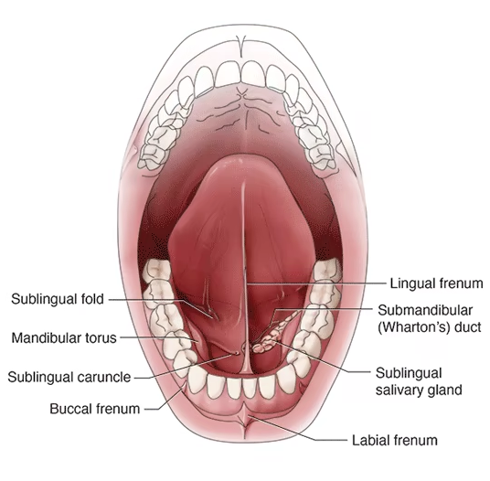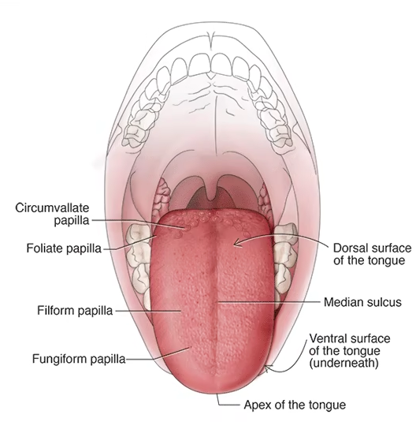
Figure ‎0-2: appearance of mouth landmarks and tongue (3).

Within the oral cavity include the upper and lower teeth, fundamental component the tongue, salivary glands, and the mucosal lining of the hard palate which features rugae (3).
This space perfectly connects to the pharyngeal cavity, a more complex mechanism that facilitates the movement of both nutrients and oxygen (4). The adaptability of the oral cavity enables it to execute various physiological tasks efficiently (5). Mucosal Immunity in the Oral Cavity Environmental Cross-Talk and Defense Mechanism, the oral cavity environment is crucial for immune regulation, as it involves a complex interaction between the host’s immune system and the resident microbial communities (6).
A typical example of this interaction is periodontal disease, in which an imbalance in microbial populations (dysbiosis) and a compromised immune response result in chronic inflammation and tissue destruction (7). Macrophages, which are essential immune cells, play a central role in this immunological process (8). They can polarize into two main phenotypes: M1 (pro-inflammatory) and M2 (immune-modulatory), depending on environmental signals and local cytokine profiles (9). These phenotypes are functionally distinct; M1 macrophages primarily regulate inflammation by producing cytokines, while M2 macrophages are involved in tissue repair and resolution of inflammation (10).
An imbalance in the activity between M1 and M2 macrophages often drives disease progression. M1 macrophages release pro-inflammatory cytokines such as interleukin-1β (IL-1β) and tumor necrosis factor-alpha (TNF-α), both of which intensify the inflammatory response and promote tissue damage (11).
Moreover, matrix metalloproteinase (MMPs), particularly MMP-9, contribute to extracellular matrix degradation and facilitate immune cell migration, linking the local immune response in the oral cavity to broader immune-mediated pathology (12). Environmental Factors in the Oral Cavity and Their Impact on Microbial Diversity The oral cavity is a highly complex environment that supports a diverse and dynamic microbial ecosystem. This ecosystem is shaped by numerous factors, including dietary habits, oral hygiene practices, and various ecological pressures (13). Early bacterial colonizers, such as Streptococcus mitis and Streptococcus sanguinis, play a crucial role in the initial stages of oral microbial colonization. These species help pave the way for the formation of polymicrobial biofilms, including dental plaque (14).
Over time, changes in diet—especially those favoring carbohydrate-rich foods—have significantly altered the composition of the oral microbiota. This shift promotes the proliferation of acidogenic and pathogenic bacteria that are strongly linked to caries and periodontal diseases (15).
While daily oral hygiene practices such as brushing and flossing are essential to disrupt biofilm formation, they can also alter the microbial landscape by introducing new microorganisms or displacing existing populations (16).
Importantly, growing evidence indicates that the oral microbiota exerts systemic effects, with associations established between oral pathogens and diseases affecting the heart, brain, and other organs. This underscores the importance of maintaining microbial balance in the oral cavity to support overall health (17).
The oral mucosal surfaces and epithelial cells also contribute significantly to shaping microbial ecosystems (18).
Microorganisms in the oral cavity interact intricately with mucosal secretions, particularly mucins. For instance, beneficial species such as Streptococcus salivarius metabolize mucins as a nutrient source. This not only sustains their growth but also generates metabolic byproducts that support epithelial cell health and maintain microbial harmony (19).
Conversely, pathogenic species like Porphyromonas gingivalis exploit mucins to penetrate epithelial barriers, contributing to inflammatory processes and the development of conditions such as periodontitis (20). Furthermore, mucins facilitate the formation of microbial biofilms like dental plaque, which can either be protective or pathogenic depending on the composition and metabolic activity of the microorganisms involved (21). Pathogenic microorganisms in the oral cavity, such as Porphyromonas gingivalis, are strongly linked to periodontitis. These bacteria have developed mechanisms to evade the host immune response (22). One strategy is the inhibition of phagocytosis by immune cells like neutrophils and macrophages. Additionally, P. gingivalis can modulate cytokine production to promote a pro-inflammatory environment, which leads to tissue damage (23). Moreover, these pathogens form biofilms that resist immune clearance and antimicrobial treatments.
When immune regulation fails, chronic inflammation and tissue destruction occur (24). Such immune dysregulation has systemic consequences, for example, the association between periodontitis and cardiovascular diseases (25). These non-cancerous growths arise from neural tissues in the oral cavity. Despite sharing a neural origin, they display notable diversity in microscopic structure and pathological features (26). Common examples include schwannomas, neurofibromas, traumatic neuromas, granular cell tumors (GCTs), and palisaded encapsulated neuromas (PENs) (27). Typically, these tumors are well-defined or encapsulated and composed of Schwann cells, fibroblasts, and occasionally axons (28). They are usually non-invasive, with distinct histological characteristics that differ across tumor subtypes (29). Their encapsulation and cellular composition further distinguish them from malignant counterparts (30). Ranking as the sixth most prevalent cancer worldwide, oral malignancies represent a significant public health burden, particularly in regions with high tobacco and alcohol use (31).
Squamous cell carcinoma (SCC) dominates oral malignancies, though rare forms like melanomas, sarcomas, and lymphomas are also documented (32). A key epidemiological challenge arises from conflating oral and pharyngeal cancers in studies, obscuring site-specific biological traits (33). Research spanning 1970–2006 highlights associations between incidence rates, survival outcomes, and demographic factors like age and ethnicity (34). Early detection remains critical for improving outcomes, especially for aggressive tumors (35).

Saliva enables non-invasive, real-time tracking of oral SCC progression and therapeutic responses through biomarker analysis (36). Its diagnostic utility extends to head and neck squamous cell carcinomas (HNSCC), aiding in prognosis and treatment evaluation (37). While some salivary components may suppress tumor initiation, others paradoxically promote metastasis in specific contexts (38). Salivary biomarkers, when combined with clinicopathological data, enhance HNSCC detection accuracy (39). However, clinical adoption remains limited, necessitating deeper exploration of saliva’s dual roles in tumor behavior (40). Chronic infections drive carcinogenesis via persistent inflammation and tissue damage (41).
Pathogens like H. pylori, HPV, and hepatitis viruses account for 30% of infection-linked cancers (42). Dysbiosis and non-commensal microbes further contribute to pro-inflammatory microenvironments, increasing risks for lymphomas and leukemias (43). Targeting gut microbiota modulation offers promising preventive strategies (44). Early diagnosis of oral cancer relies primarily on the Piggy pencil, which is considered the gold standard for screening. Promising screening tools are used in patients with specific oral lesions (45).
Imaging techniques such as panoramic radiography (DPT), CT, and MRI help detect lymph node metastasis. Recently, a light-emitting detection system with improved specificity has been introduced (46). Future diagnostic methods may include serum and gamete analysis using biomarkers such as cytokines and hypermethylation promoters. These tools aim to support early detection in non-specialized settings (47). Early diagnosis reduces treatment complications and improves survival rates. The integration of biomarkers may provide new insight into early-stage detection (48). Treatment depends on the cancer stage and the patient’s health. Surgery is often the first line of treatment for early tumors (49). Radiotherapy is commonly used post-surgery to prevent recurrence. In advanced stages, chemotherapy such as cisplatin is added to control metastasis (50). Targeted therapies like cetuximab improve outcomes by acting on specific cancer cell receptors. Newer options like gene therapy and immunotherapy are being explored for resistant cases (51). These therapies aim to enhance survival and improve the patient’s quality of life. Personalized treatment plans are increasingly becoming standard practice (52).
Certain infections, like HPV, are key in the development of oral squamous cell carcinoma (OSCC). Risk factors include smoking, alcohol, and tobacco chewing (53). HPV is a known oncogenic virus linked to oral cancer. Detection involves identifying viral DNA through molecular techniques (54). Histopathology helps visualize HPV-related cellular abnormalities. Genetic mutations, such as those in RasL, offer further diagnostic clues (55).
Combining viral and genetic data enhances diagnostic accuracy and treatment decisions. This integrated approach may personalize management plans (56). Immunotherapy has significantly improved survival in many cancer types including OSCC. Immune checkpoint inhibitors (ICIs) are key drugs in this field (57). These drugs restore immune function by blocking inhibitory signals in T-cells. PD-1 and PD-L1 are critical molecules in this immune escape pathway (58). Drugs like pembrolizumab and nivolumab showed effectiveness in head and neck cancers. They also present fewer side effects compared to chemotherapy (59). Regulatory T-cells (Tregs) increase PD-L1 expression, helping tumors evade the immune system. Understanding this can guide future immune-based treatments (60). Stem cells help repair tissues damaged by cancer treatments like radiation and chemotherapy. They are also being used to deliver anti-cancer agents directly to tumor sites (61). Cancer stem cells drive tumor growth and metastasis. Targeting them could prevent recurrence and improve long-term outcomes (62).

Goals
- To investigate the dual role of the oral microbiome in maintaining oral homeostasis versus triggering pathological processes, with a focus on theoretical mechanisms linking microbial dysbiosis to immune imbalance and malignant transformation.
- To analyze the theoretical framework connecting chronic microbial-induced inflammation to oncogenic signaling pathways, emphasizing disruptions in cellular communication and immune modulation.
- To explore the theoretical basis of saliva as a dynamic biological medium, focusing on its molecular composition and interactions with oral malignancies.
- To conceptualize the role of oncogenic infections (e.g., HPV) in oral carcinogenesis, emphasizing viral-host interactions and genetic/epigenetic alterations.
- To theorize the interplay between the oral microenvironment, mucosal immunity, and microbial communities in health and disease progression.
- To model the ecological dynamics of mucus-microbe-cell interactions in maintaining microbial equilibrium or facilitating pathogen colonization.

Questions
- How do chronic inflammatory mediators, derived from microbial dysbiosis, theoretically contribute to DNA damage and tumorigenesis in the oral cavity?
- What molecular mechanisms underlie saliva’s capacity to reflect systemic and local tumor activity, and how might these inform theoretical models of cancer progression?
- How does the polarization balance of M1/M2 macrophages theoretically influence immune tolerance or hyper activation in periodontal disease?
- What ecological principles govern the symbiotic relationship between commensal oral microbes (e.g., Streptococcus spp.) and host immunity in preventing dysbiosis?
- What theoretical limitations exist in current models of early oral cancer detection, and how might emerging biomarker technologies address these gaps?
- How do oncogenic pathogens like HPV theoretically hijack host signaling pathways to drive oral squamous cell carcinoma (OSCC) development?

Objectives
- To develop a theoretical model of immune-microbial crosstalk in the oral cavity, emphasizing how dysregulated cytokine networks (e.g., IL-1β, TNFα) and macrophage polarization drive chronic inflammation and carcinogenesis.
- To conceptualize the role of saliva as a mirror of tumor microenvironment dynamics, focusing on biomarker stability, variability, and theoretical frameworks for non-invasive monitoring.
- To theorize the ecological succession of oral microbiota, from colonization by pioneer species (Streptococcus mitis) to dysbiotic states favoring pathogens (Porphyromonas gingivalis), and its implications for mucosal immunity.
- To outline a molecular pathway model linking HPV-mediated epigenetic modifications (e.g., p53 inactivation) to OSCC progression, integrating viral persistence and host genetic susceptibility.
- To hypothesize the dual role of mucus in oral ecology, balancing nutrient provision for commensals versus serving as a substrate for pathogenic biofilm formation.
- To critically evaluate theoretical paradigms of the oral cancer microenvironment, including immune evasion mechanisms (e.g., PD-1/PD-L1 axis) and stromal cell interactions.

Chapter Two
Method

- Chapter Two: Method
  - Table Formation Methodology, and Rationale for Table Selection

Methodology for Table Construction
- Pathogen Selection: Microorganisms associated with oral infections (e.g., viruses, bacteria, fungi) were prioritized for inclusion in the table.
- Clinical Condition Association: Each pathogen was linked to specific inflammatory or disease outcomes, such as herpangina or oral hairy leukoplakia.
- Anatomic Localization: The primary sites of infection (e.g., tongue dorsum, buccal mucosa) were documented to contextualize pathogen activity.
- Integration of Research Evidence: Peer-reviewed studies validating the role of each pathogen in oral pathologies were incorporated, including titles, authors, and publication years.
- Reference Standardization: Numbered citations were systematically assigned to ensure traceability and alignment with academic conventions.

Reasons for Choosing This Table Format: -
- Clarity: The structured categorization of pathogens, associated conditions, anatomic sites, and supporting evidence simplifies complex pathogen-disease relationships.
- Comprehensive Evidence: Emphasis was placed on peer-reviewed research to establish scientific validity for each pathogen’s role in oral pathologies.
- Clinical Relevance: Mapping infections to specific anatomic locations (e.g., soft palate, gingiva) enhances diagnostic and therapeutic precision.
- Comparative Utility: The format facilitates cross-analysis of diverse pathogens (viruses, bacteria, fungi) and their clinical impacts.
- Mechanistic Focus: Pathogen-specific mechanisms, such as biofilm formation and immune evasion, were highlighted to provide insights into disease progression.
- Academic Standardization: Consistent formatting and citation practices align with guidelines for systematic reviews, ensuring reproducibility and rigor.
  - Keywords

Core Keywords: -
- Oral infections / Oral mucosal diseases
- Pathogen-host interactions
- Oral microbiota dysbiosis
- Clinical manifestations of oral infections
- Immune response in oral mucosa
- Oral microbiota
- Oral squamous cell carcinoma (OSCC)
- Oral carcinogenesis
- Host-microbe interactions
- Microbial dysbiosis
- Oral potentially malignant disorders (OPMDs)
- Cytokines / Pro-inflammatory cytokines
- Oral squamous cell carcinoma (OSCC)
- Tumor microenvironment (TME)
- Cancer-associated inflammation
- Immune modulation in cancer
- Oral cancer cell invasion / Oral cancer progression
- Periodontal disease / Gingivitis / Tooth mobility
- Cytokine signaling / Pro-inflammatory cytokines
- Host-microbe interactions / Oral microbiota dysbiosis
- Immune suppression / Tumor microenvironment (TME)

Pathogen-Specific Keywords: -
- Treponema pallidum + oral syphilis + HIV co-infection
- Candida albicans + oral candidiasis + host-pathogen interactions
- Leishmania species + oral leishmaniasis + mucosal lesions
- Herpes simplex virus (HSV) + herpangina + oropharyngeal lesions
- Coxsackievirus + herpetic stomatitis + gingival inflammation
- Varicella-zoster virus (VZV) + oral chickenpox + palatal lesions
- Epstein-Barr virus (EBV) + oral hairy leukoplakia + tongue lesions
- Streptococcus group A + strawberry tongue + scarlet fever
- Staphylococcus aureus + staphylococcal mucositis + oral biofilm
- Human papillomavirus (HPV) + oropharyngeal cancer + OSCC pathogenesis
- Porphyromas gingivalis + buccal mucosa + OSCC progression
- Fusobacterium nucleatum + subgingival biofilm + periodontal pockets
- Candida albicans + oral mucosa + premalignant lesions
- Epstein-Barr Virus (EBV) + epithelial cells + B-cell interactions
- Treponema denticola + TGF-β signaling pathway + OSCC development

Cytokine-Specific Keywords:
- IL-1 + oral squamous cell tissue + tongue/gingival inflammation
- IL-6 + cancer cell invasiveness + epithelial/stromal cell interactions
- IL-8 + salivary biomarkers + radiotherapy response in head and neck cancer
- IL-10 + oral cancer susceptibility + genetic polymorphisms

Mechanistic & Clinical Keywords: -
- Viral replication in oral epithelium
- Bacterial adhesion to mucosal surfaces
- Immune evasion strategies
- Biofilm-associated infections
- Inflammation-mediated tissue damage
- Microbial immune evasion
- Chronic inflammation
- Biofilm formation
- Pathogen-induced genomic instability
- Oncogenic signaling pathways
- Chronic inflammation → cancer progression
- Immune cell infiltration (e.g., stromal cells, epithelial cells)
- Biomarker discovery (e.g., salivary IL-8)
- Genetic susceptibility (e.g., IL-10 genotypes)
- Metastasis promotion
- Oxidative stress → periodontal tissue damage
- Chronic inflammation → cancer progression
- Bacterial enzyme activity (e.g., collagenolysis, proteolysis)
- Immune evasion / angiogenesis (via VEGF)
- Microbiome-induced bone loss

Anatomic & Diagnostic Keywords:
- Tongue lesions (dorsum, ventral surface, lateral borders)
- Buccal mucosa / palate (hard/soft) / gingiva
- Oropharyngeal involvement
- Oral ulceration / erythema / plaques
- Oropharyngeal mucosa
- Gingival tissues
- Subgingival microbiome
- Oral epithelial dysplasia
- Oral mucosa / tongue / floor of the mouth
- Gingival inflammation
- Head and neck cancer subtypes

Search Combinations (Examples):
- Treponema pallidum AND oral syphilis in HIV patients
- Candida albicans AND host-pathogen interactions in oral candidiasis
- Herpes simplex virus AND herpangina in soft palate
- Streptococcus group A AND strawberry tongue pathogenesis
- Epstein-Barr virus AND oral hairy leukoplakia mechanisms
- IL-6 AND cancer cell invasiveness in OSCC
- IL-8 AND tumor microenvironment in head and neck cancer
- IL-10 polymorphisms AND oral cancer risk
- Butyrate AND oxidative stress in periodontal disease
- IL-8 AND neutrophil recruitment in oral cancer
- Gingipains AND collagen degradation in periodontitis
- LPS AND TLR4/NF-κB pathway in osteoclastogenesis
- IL-17 AND epithelial barrier disruption in oral cancer

Factor-Specific Keywords:
- Butyrate + oxidative stress + gingival epithelial cells
- IL-6/IL-8 + chronic inflammation + neutrophil recruitment
- Gingipains + collagen degradation + periodontal ligament destruction
- LPS (lipopolysaccharide) + osteoclastogenesis + TLR4/NF-κB pathway
- Hyaluronidase + hyaluronic acid degradation + gum weakening
- IL-1β + bone resorption + MMP activation
- Proteases + extracellular matrix degradation + apoptosis in fibroblasts
- TNF-α + NF-κB pathway + tissue invasion
- IL-17 + epithelial barrier disruption + neutrophil activation

Chapter Three
Results

- Chapter Three: Results
  - Types of microorganisms that cause oral inflammation and their relationship with oral cancer
Certain microorganisms are implicated in the development of cancer, particularly in the oral cavity. Epstein-Barr virus is associated with oral and nasopharyngeal cancers, whereas Candida albicans, Treponema pallidum, and Leishmania may play a role through mechanisms such as chronic inflammation. Other pathogens, including Herpes simplex virus, Varicella-zoster virus, and Coxsackievirus, have a less direct association but may contribute to conditions that favor malignant transformation (See Table 1).
Table ‎0-1: Types of microorganisms that cause oral inflammation and their relationship with oral cancer (63-71)
Microorganism Type | Inflammation Name | Infection Site | Research Title | Researcher | Y. | Ref.
Herpes Simplex Virus | Herpangina | Soft Palate Uvula  Tonsillar Pillars  Oropharynx  Posterior Pharyngeal Wall | Characteristics Of Herpes Simplex Virus Infection and Pathogenesis Suggest a Strategy for Vaccine Development | Xingli Xu | 2019 | (63)
Coxsackievirus (A, B) | Herpetic Stomatitis | Gingiva  Buccal Mucosa  Tongue (Dorsal and Ventral)  Hard And Soft Palate  Lips  Floor Of the Moth | ACUTE HERPETIC STOMATITIS: CLINICAL MANIFESTATIONS,  DIAGNOSTICS AND TREATMENT STRATEGIES | Wiad Lek | 2022 | (64)
Varicella-Zoster Virus | Chickenpox In Mouth | Tongue  Palate (Hard and Soft Palate)  Buccal Mucosa  Gingiva Oropharynx | Herpes Simplex Virus and Varicella Zoster Virus Infections in Cancer Patients | Ralph Tayyar | 2023 | (65)
Epstein-Barr virus | Oral Hairy Leukoplakia | Lateral Borders of the Tongue  Ventral Surface of the Tongue  Dorsum of the Tongue  Buccal Mucosa | Epstein–Barr virus in the pathogenesis of oral cancers | Jt  guidray | 2018 | (66)
Streptococcus group | Strawberry Tongue | Dorsum of the Tongue  Papillae of the Tongue  Tip of the Tongue | Group A Streptococcus | Judith M. Martin MD | 2007 | (67)
Staphylococcus aureus | Staphylococcal Mucositis | Buccal Mucosa  Palate (Hard and Soft Palate  Tongue  Gingiva  Oropharynx | Staphylococcus aureus and the oral cavity | M.G. McCormack BDS | 2015 | (68)
Treponema pallidum | Primary Syphilis | Tongue (most common site in the oral cavity)  Lips  Palate (hard or soft palate)  Tonsils  Gingiva | Unexpectedly high prevalence of Treponema pallidum infection in the oral cavity of human immunodeficiency virus-infected patients with early syphilis who had engaged in unprotected sex practices | C.-J. Yang | 2015 | (69)
Candida albicans | Acute Oral Candidiasis | Tongue  Dorsum of the Tongue  Ventral Surface of the Tongue  Buccal Mucosa  Palate - Hard & Soft Palate  Gingiva | Host–pathogen interactions and virulence-associated genes during Candida albicans oral infections | Ronny Martin | 2011 | (70)
Leishmania species | leishmaniasis | Buccal Mucosa  Palate - Hard & Soft Palate  Tongue - Dorsum & Ventral Surface  Gingiva | Leishmaniasis with oral mucosa involvement | Ana C. A. Pellicioli | 2012 | (71)

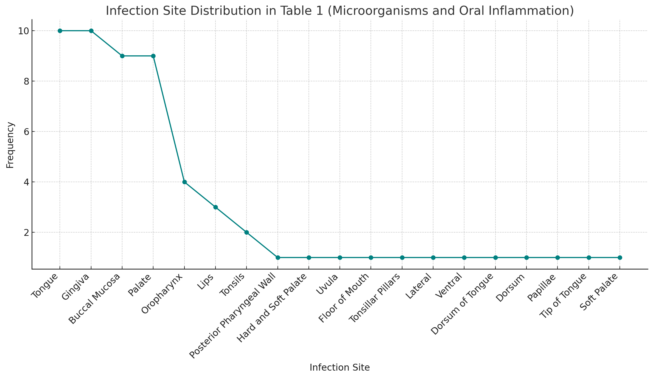
Figure 3-1: Infection Site Distribution In (Microorganisms And Oral Inflammation)
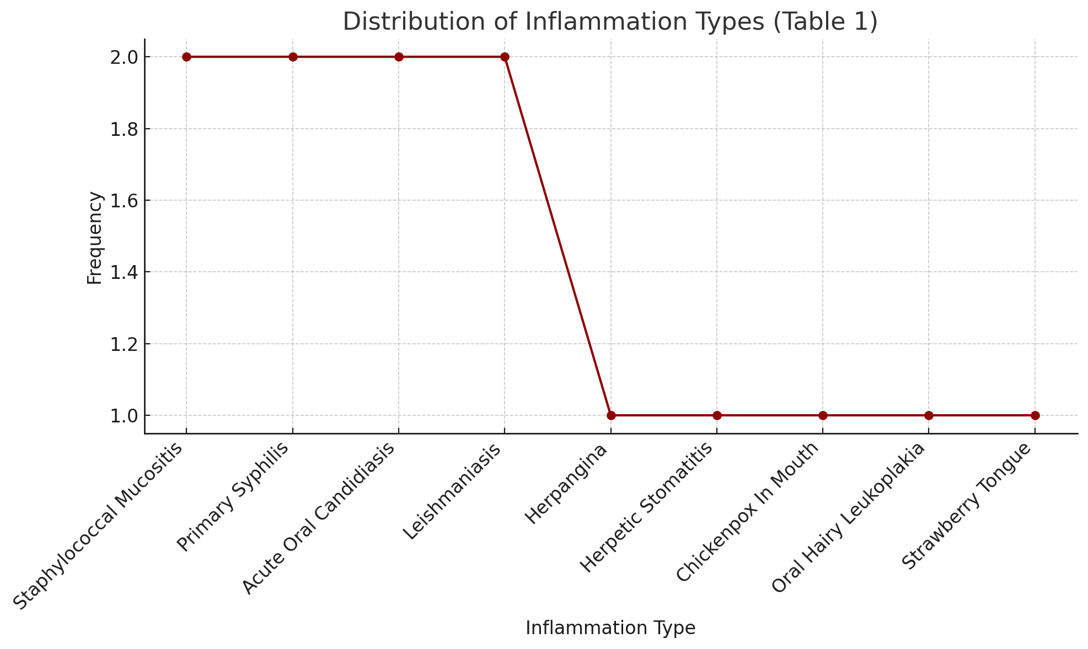
Figure ‎0-2: Distribution Of Inflammation Types

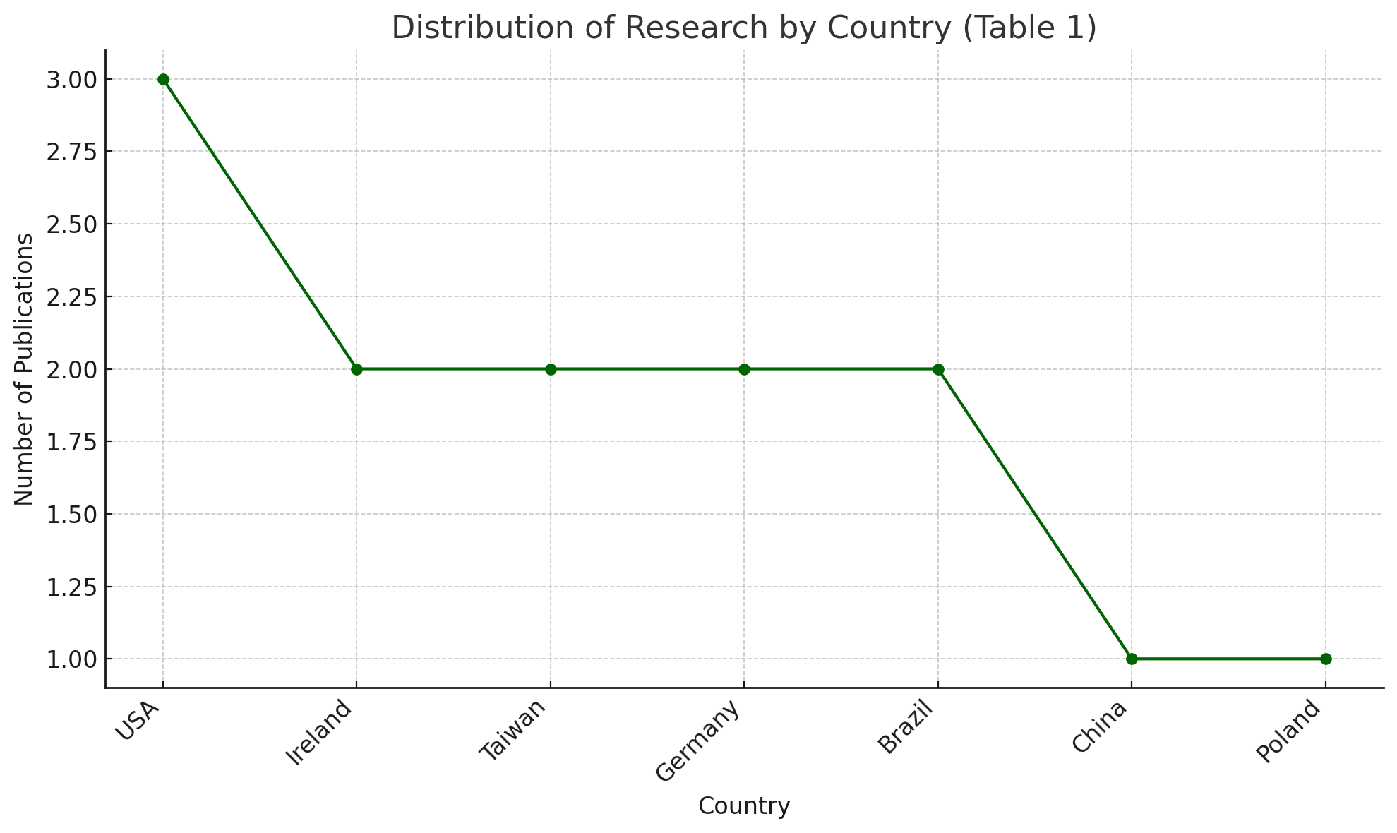
Figure ‎0-3: Distribution of Research by Country.

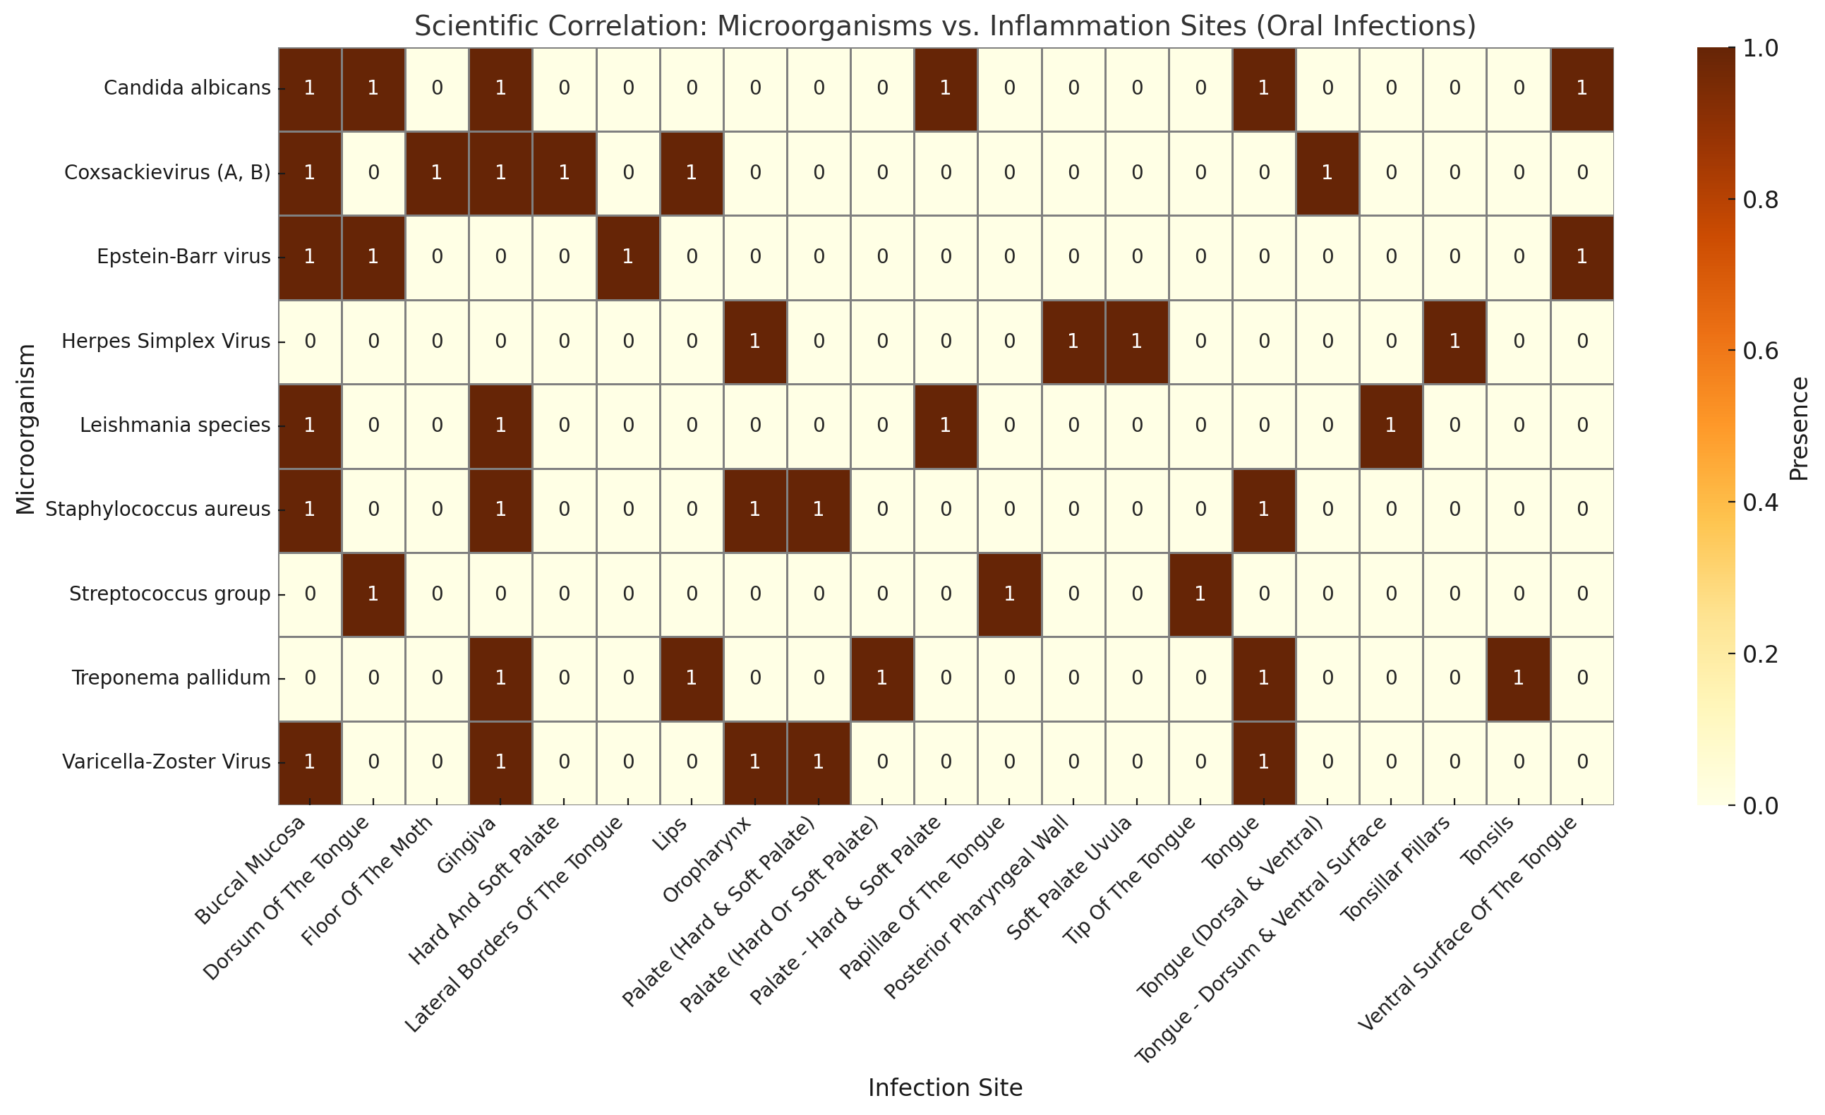
Figure ‎0-4: Scientific Correlation: Microorganisms vs. Inflammation Sites (Oral Infections).

  - Types of microorganisms and their relationship with oral cancer:
Certain viruses, bacteria, and fungi play a role in cancer. HPV and EBV, for example, can slip into human DNA and turn on cancer-driving genes. Meanwhile, bacteria like Porphyromonas and Fusobacterium along with fungi such as Candida, fuel long-term inflammation that may lead to tumors. See Table 2.
Table ‎0-2: Types of microorganisms and their relationship with oral cancer (72-77)
Microorganisms type | Type of cancer | Infection site | Research title | researcher | Y. | Ref.
Human papilloma virus | OSCC | oropharyngeal | Oral microbiota and oral squamous cell carcinoma | Kasra javadi | 2024 | (72)
Porphyromonas gingivalis | OSCC | buccal mucosa of OSCC patients | The Oral Microbiota May Have Influence on Oral Cancer | Chen Ping Zhang | 2020 | (73)
Fusobacterium nucleatum | OSCC | oral cavity, especially in the subgingival biofilm and periodontal pockets. | Oral microbiota and oral squamous cell carcinoma | Bayu Indra Sukmana1 | 2024 | (74)
Candida albicans | oral Potentially Malignant Disorders | Oral cavity  Oral mucosa  Gingiva  Oropharynx | Role of Candida albicans in Oral Carcinogenesis | muhammedchalim | 2022 | (75)
Epstein–Barr Virus | OSCC | Epithelial Cells  B-cell | Epstein–Barr Virus—Oral Bacterial Link in the Development of Oral Squamous Cell Carcinoma | Daniela Núñez-Acurio | 2020 | (76)
Treponema denticola | OSCC | Oral Tissues | Treponema denticola Promotes OSCC Development via the TGF-β Signaling  Pathway | x.peng | 2022 | (77)

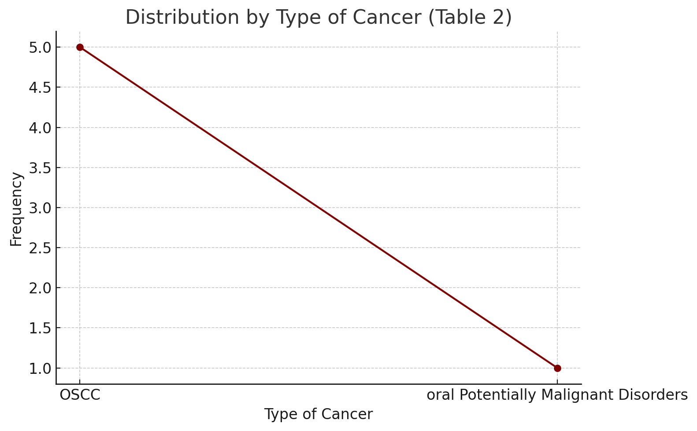
Figure ‎0-5: Distribution by Type of Cancer.

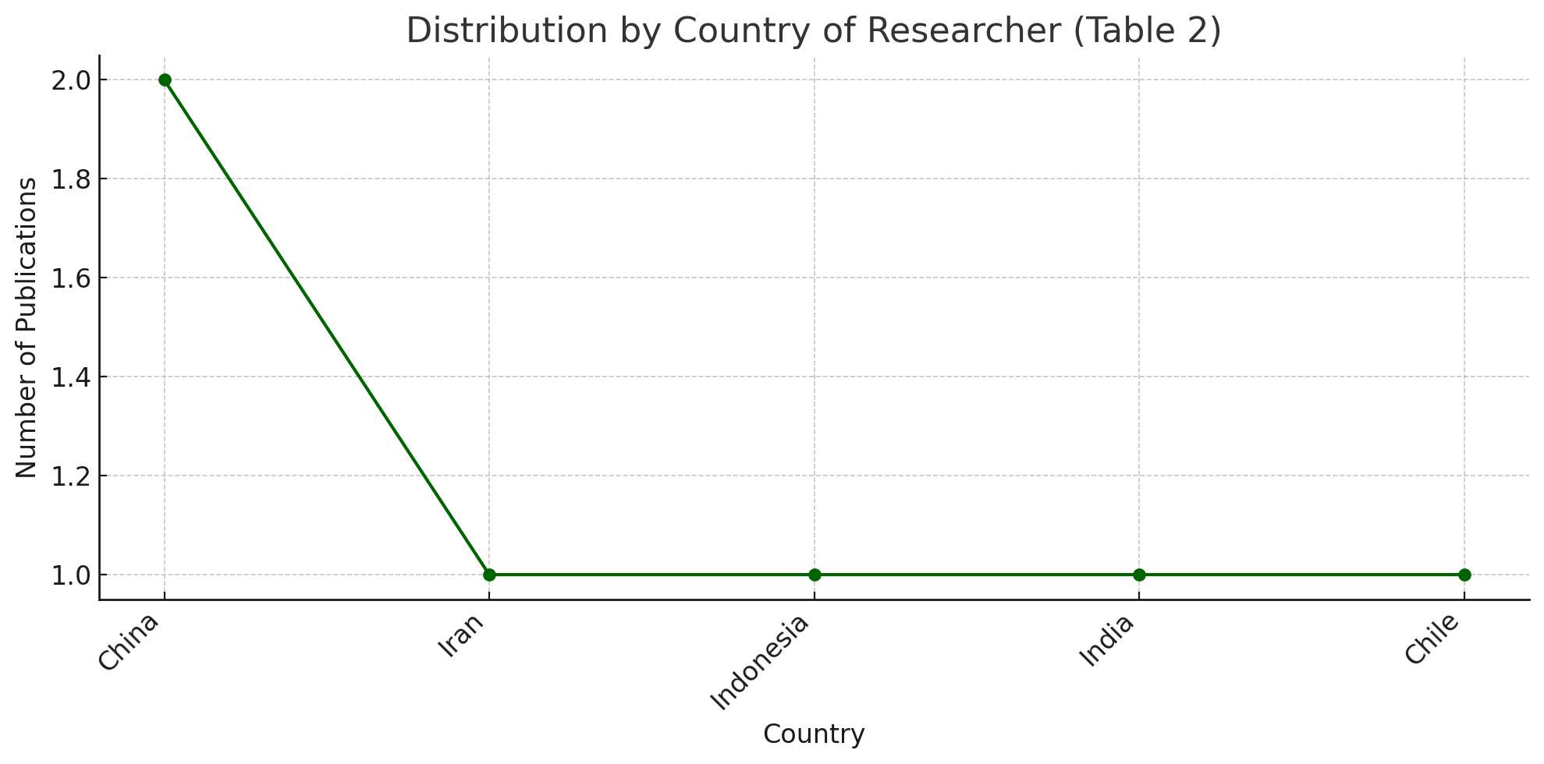
Figure ‎0-6: Distribution by Country of Researcher.

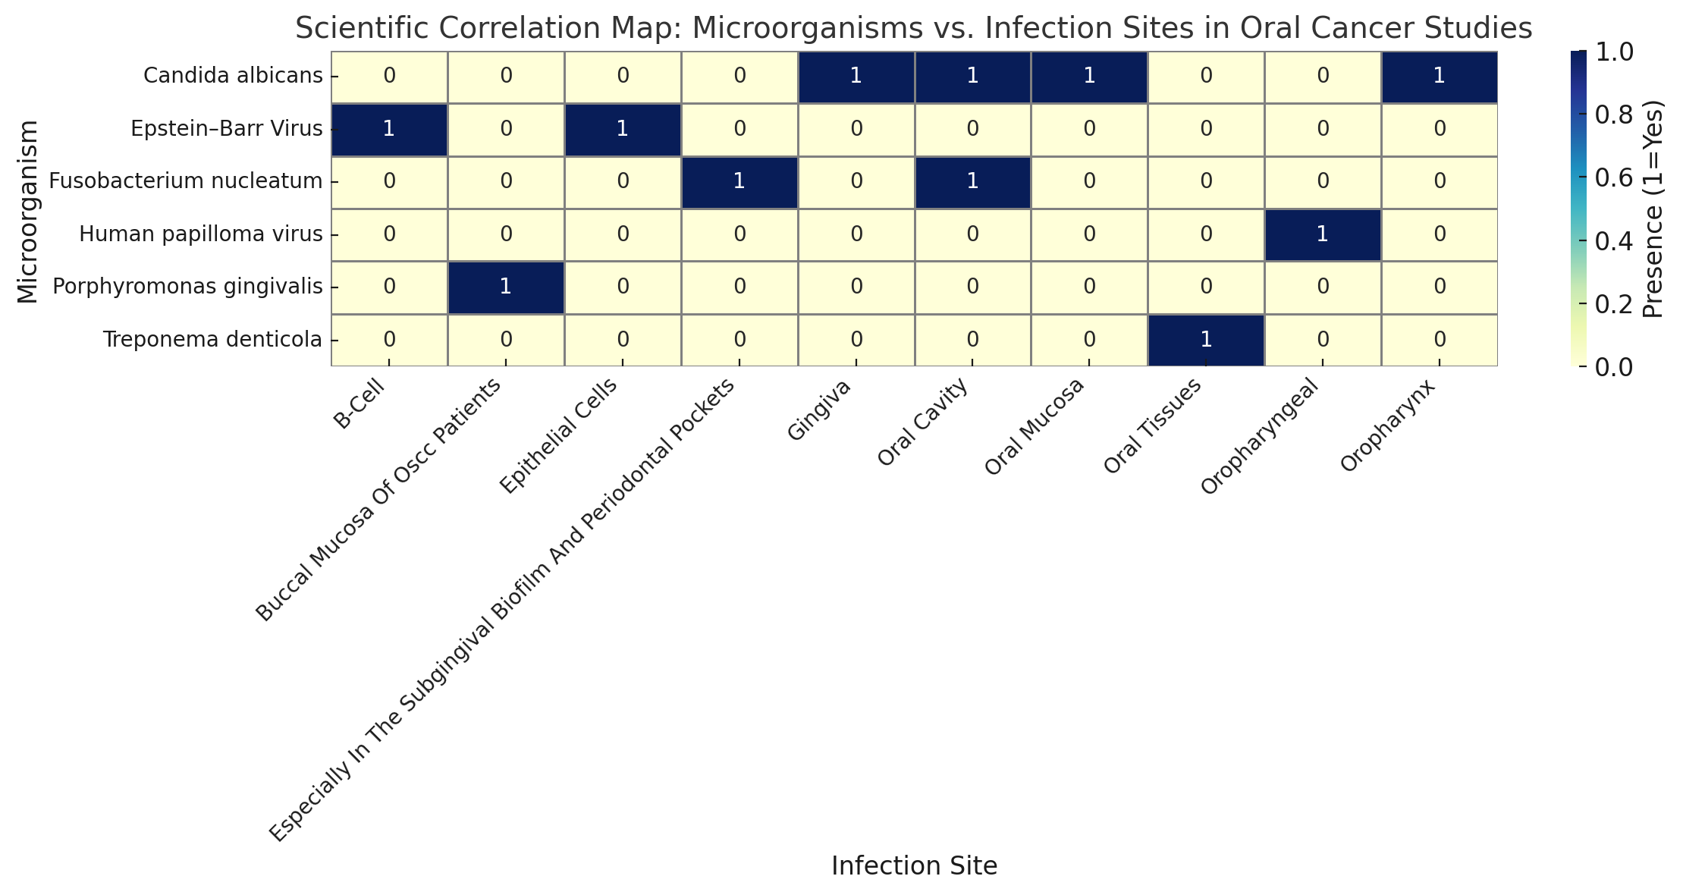
Figure ‎0-7: Scientific Correlation Map: Microorganisms vs. Infection Sites in Oral Cancer Studies.

  - Interleukins and Cancer
IL-6 and IL-8 act as cancer's allies, sparking inflammation and building tumor blood supply. Meanwhile, IL-10 and IL-1 work behind the scenes, dampening immune defenses to give tumors a survival edge This cytokine trio orchestrates a perfect environment for cancer to thrive undetected (See Table 3).
Table 3-3: Cytokine Expression and Their Impact on Oral Squamous Cell Carcinoma Development (78-81).
Ref. | Y. | researcher | Research title | Inflammation sites | Type of cancer | Cytokine
(78) | 2020 | cedric Rebe | Interleukin-1β and Cancer | Tongue  gingiva  Floor of mouth | oral squamous cell tissue | IL-1
(79) | 2022 | Anna Venhauerová | The Role of IL-6 in Cancer Cell Invasiveness and Metastasis | Immune cells  Epithelial cells  Stromal cells | Oral squamous cell tissue | IL-6
(80) | 2021 | jose bagan | Salivary IL-8 as a putative predictive biomarker of radiotherapy response in head and neck cancer patients | Tumor Microenvironment (TME)  Oral Mucosa | oral squamous cell tissue | IL-8
(81) | 2019 | Rosnah mond zain | Association of Interleukin-10 Genotypes and Oral Cancer Susceptibility in Selected Malaysian Population | lips  Tongue  Oral cavity | oral squamous cell tissue | IL-10

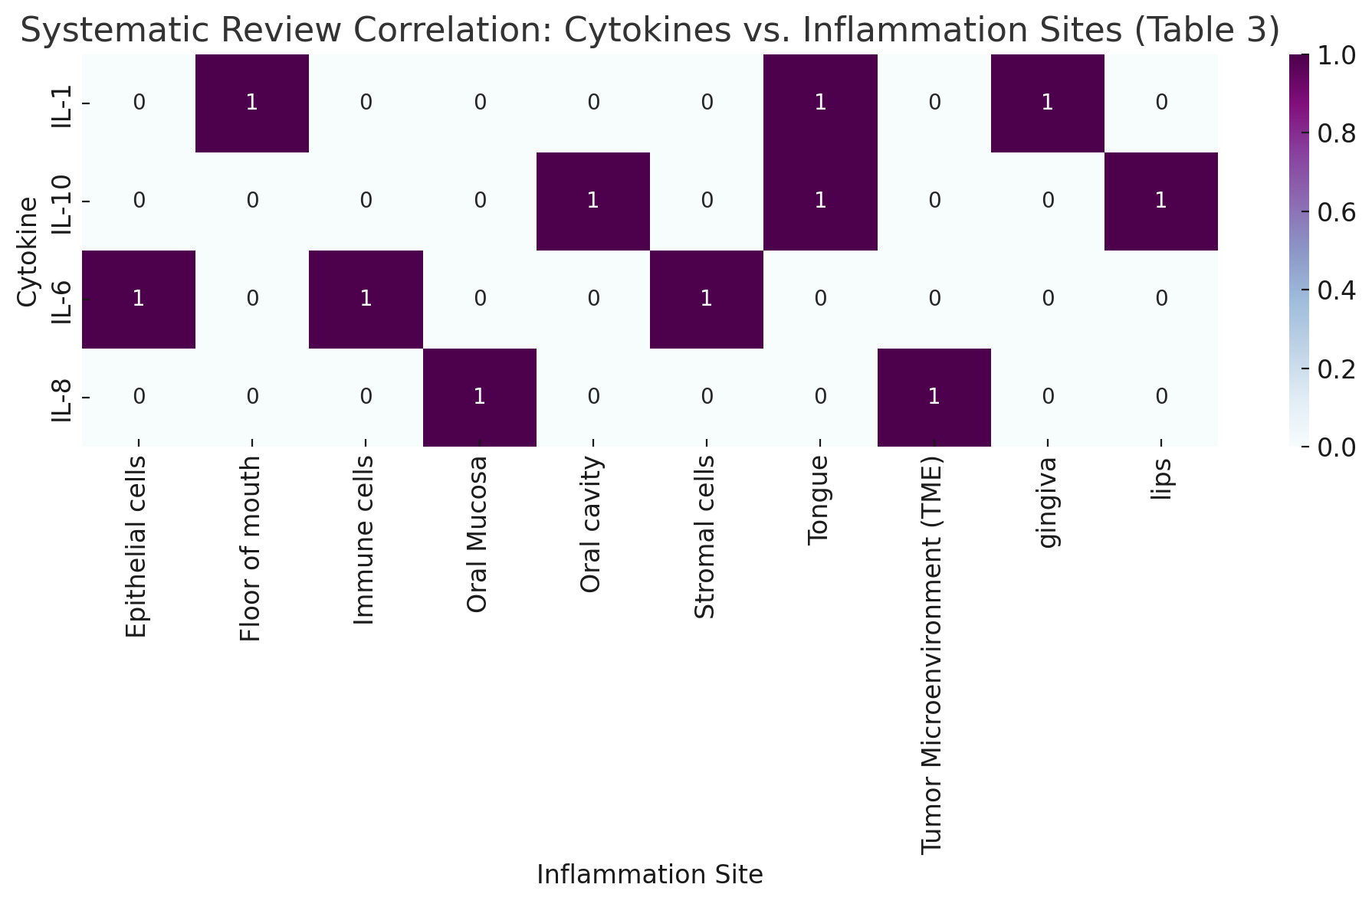
Figure ‎0-8: Systematic Review Correlation: Cytokines vs. Inflammation Sites.

  - Cytokines in Oral Cancer and Infection: Roles, Research, and References: -
This table summarizes the pivotal roles of various cytokines in oral cancer progression and infection mechanisms. It highlights recent and foundational studies, detailing researchers, publication years, and key findings on cytokine-mediated pathways. The included references provide a resource for further exploration into cytokine interactions and their therapeutic implications. See Table 4.
Table 3-4: Cytokines in Oral Cancer and Infection (82-86).
Ref. | Y. | researcher | Research title | Role in oral cancer/Infection | Cytokine
(82) | 2018 | Tsukamoto, H | IL-6-Mediated Suppression of miR-200c Directs Cytokine-Induced Symmetric Division in Cancer | Promotes tumor cell proliferation and survival. and suppresses anti-tumor T-cell responses. | IL-6
(83) | 2019 | Alfaro, C | Interleukin-8 in Cancer Pathogenesis, Treatment, and Resistance | Recruits’ neutrophils, fueling inflammation. and Stimulates angiogenesis (via VEGF) | IL-8
(84) | 2008 | Sethi, G | TNF: A master switch for inflammation to cancer. | Induces apoptosis in normal cells but promotes tumor survival via NF-κB. and Enhances tissue invasion. | TNF-α
(85) | 2022 | Marchesan, J | IL-1 Mediates Microbiome-Induced Inflamm-Aging and Bone Loss in Mice. | Drives chronic inflammation and bone resorption. and Activates MMPs (collagen degradation) | IL-1β
(86) | 2002 | Gaffen, S | Regulation of Host-Microbe Interactions at Oral Mucosal Barriers by Type 17 Immunity. | Promotes neutrophil recruitment and epithelial barrier disruption. | IL-17

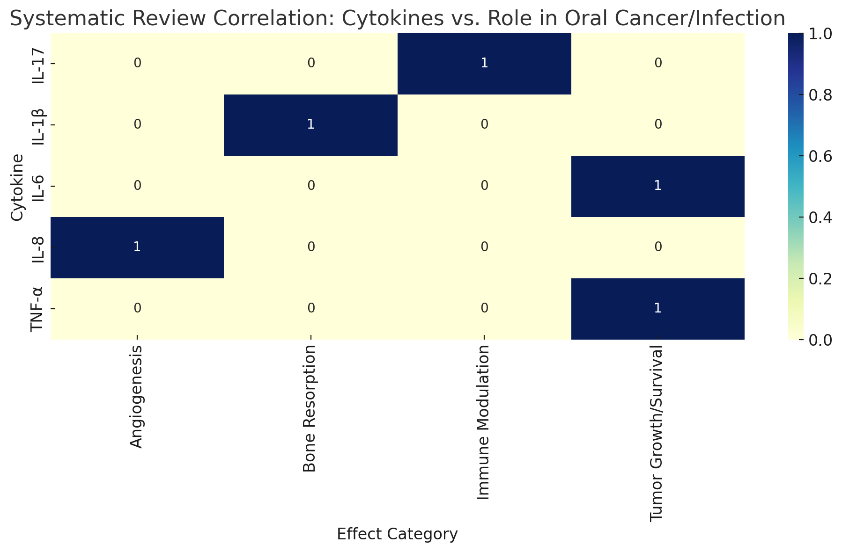
Figure 3-9: Systematic Review Correlation: Cytokines vs. Role in Oral Cancer/Infection.
  - Oral Cancer-Related Factors and Their Impact on Dental Health: Mechanisms and Research Insights: -
This table outlines key biological factors linked to oral cancer and their detrimental effects on dental integrity, such as inflammation, tissue degradation, and bone resorption. It compiles recent studies detailing how molecules like butyrate, cytokines, and bacterial enzymes contribute to periodontal disease and tooth instability. The referenced research underscores potential therapeutic targets and emphasizes the interplay between oral carcinogenesis and dental health deterioration (See Table 5).
Table 3-5: Oral Cancer-Related Factors and Their Impact on Dental Health (87-93).
Ref. | Y. | researcher | Research title | Effect on teeth | Serration of oral cancer cell
87)) | 2021 | Li, X | Butyrate from Periodontal Pathogens Suppresses Antioxidant Defenses in Gingival Epithelial Cells. | Induces oxidative stress in gingival cells, promoting periodontal disease (bone loss, loose teeth) | Butyrate
(88) | 2015 | Hajishengallis | Periodontitis: From Microbial Immune Subversion to Systemic Inflammation | Triggers chronic inflammation, accelerating gingivitis and periodontitis, which destabilize teeth. | IL-6/IL-8
(89) | 2016 | Sztukowska, M. N | Collagenolytic Activity of Gingipains Drives Periodontal Tissue Destruction | Degrade collagen in the periodontal ligament, leading to tooth mobility. | Gingipains
90)) | 2020 | Liu, J | Porphyromonas gingivalis Lipopolysaccharide Promotes Osteoclastogenesis via the TLR4/NF-κB Pathway | Activates osteoclasts, causing bone resorption around tooth roots | LPS (lipopolysaccharide)
91)) | 2018 | Chen, H | Microbial Hyaluronidase: A Double-Edged Sword in Periodontal Disease | Breaks down hyaluronic acid in gums, weakening tooth support | Hyaluronidase
(92) | 2012 | Hasturk, H | Resolvin E1 Regulates Inflammation at the Cellular and Tissue Level and Restores Tissue Homeostasis in Periodontitis | Promotes gum inflammation, increasing risk of tooth decay and gingival recession | IL-1β
93)) | 1999 | DeCarlo, A | Gingipains from Porphyromonas gingivalis Induce Apoptosis in Human Gingival Fibroblasts and Degrade Extracellular Matrix | Degrade tooth-supporting tissues (e.g., periodontal ligament), leading to tooth loss. | Proteases

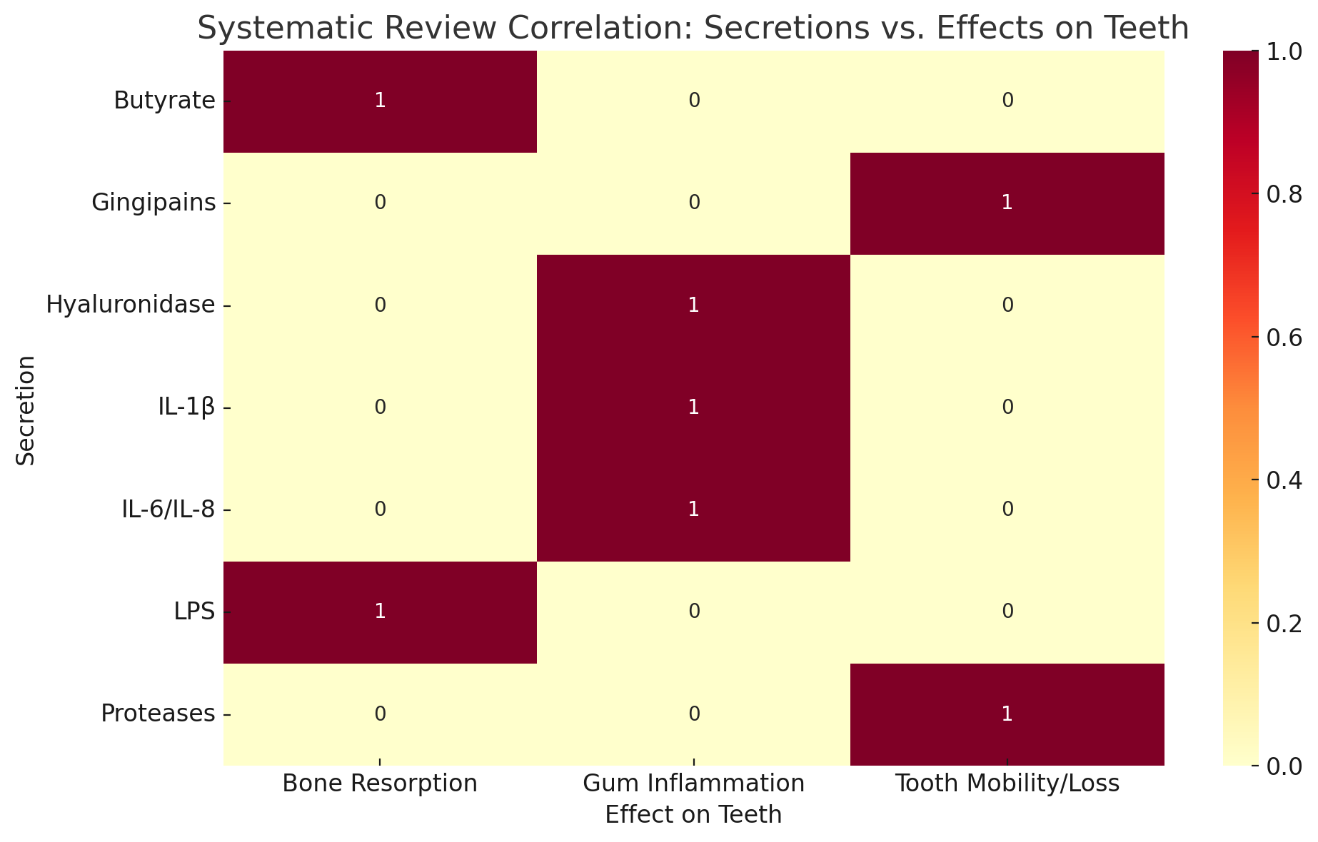
Figure ‎0-10: Systematic Review Correlation: Secretions vs. Effects on Teeth.

Chapter Four
Discussion

- Chapter Four: Discussion
  - Types of microorganisms that cause oral inflammation and their relationship with oral cancer: -
Herpes simplex virus (HSV) is a widespread viral infection that mainly targets the mucosal tissues of the mouth and genital areas. When it affects the oral cavity, it often involves the soft palate, uvula, tonsillar pillars, oropharynx, and the back of the throat, with early symptoms sometimes resembling those of bacterial pharyngitis. Investigating how HSV infects cells and evades the immune system is essential for informing the design of effective vaccines in the future (94).
Acute herpetic stomatitis is a primary infection typically caused by herpes simplex virus type 1 (HSV-1) and is most frequently seen in young children. The condition is characterized by the development of painful ulcerative lesions that can appear on the gingiva, buccal mucosa, lips, tongue (both dorsal and ventral surfaces), floor of the mouth, as well as the hard and soft palate (95).
Prompt diagnosis and supportive care are crucial to alleviate symptoms, promote healing, and reduce the risk of complications such as secondary bacterial infections or dehydration due to oral discomfort.
The varicella-zoster virus (VZV), responsible for chickenpox, can also lead to painful blister-like eruptions in the oral mucosa. These lesions may appear on the tongue, hard and soft palate, inner cheeks, gums, and throat (96).
In immunosuppressed patients, such as those undergoing cancer treatment, the infection can be more aggressive, necessitating immediate antiviral intervention.
Distinguishing VZV from HSV infections is vital for proper clinical management, as the two conditions share similar features but require different therapeutic approaches (97).
Epstein-Barr virus (EBV) is linked to oral hairy leukoplakia, characterized by thick, white patches that cannot be scraped off.
These lesions most frequently appear on the sides of the tongue but can also affect the undersurface, top of the tongue, and inner cheeks (98).
This condition is particularly prevalent in immunocompromised patients, especially those with HIV/AIDS.
Additionally, EBV plays a role in the development of some oral malignancies, as it can trigger abnormal changes in epithelial cells, contributing to cancerous transformation (99).
Group A Streptococcus (GAS) infections can produce a distinctive “strawberry tongue” appearance, characterized by a bright red, swollen tongue with enlarged papillae, giving a bumpy texture.
This manifestation typically involves the top surface, tip, and taste buds of the tongue and is a hallmark feature of scarlet fever, caused by GAS (100).
Timely identification and appropriate antibiotic therapy are critical to reduce symptom severity and prevent potential complications, such as rheumatic fever or kidney inflammation.
Staphylococcal mucositis, caused by Staphylococcus aureus, presents with painful inflammatory lesions affecting the oral mucosa, particularly the inner cheeks (buccal mucosa) and both hard and soft palates (101).
This condition primarily occurs in immunocompromised patients and can cause considerable oral discomfort.
Prompt diagnosis and targeted antibiotic therapy are essential to control the infection, alleviate symptoms, and prevent systemic spread in vulnerable individuals (102).
Treponema pallidum, the bacterium that causes syphilis, can cause primary syphilis, characterized by painless ulcers in the oral cavity, particularly on the tongue, lips, hard and soft palate, tonsils, and gums. For this reason, the unexpectedly comprehensive view of Treponema pallidum infection in the eyes with low HIV prevalence, especially among those affected by full-stage syphilis, also emphasizes unprotected sex. To be identified and diagnosed, key managers must determine its significance (103).
Candida albicans is the most common fungus causing acute oral candidiasis, which appears as creamy white plaques or red lesions on the dorsal and ventral surfaces of the tongue, oral mucosa, hard and soft palate, and gingiva. It often affects immunocompromised individuals or those taking antibiotics or corticosteroids(104).
Understanding host-pathogen interactions is fundamental to managing recurrent infections and targeting virus-associated genes.
Leishmaniasis, caused by Leishmania species, is rarely recognized as ulcerative or nodular lesions on the skin, gums, tongue (both superficial and ventral), and the hard and soft palate. Clinical manifestations are more common in cutaneous leishmaniasis and may cause discomfort, bleeding, or secondary infections. A definitive diagnosis and antiparasitic testing are essential (105).

  - Types of microorganisms and their relationship with oral cancer: -
    - 4.2.1 Human Papillomavirus:
particularly type 16, shows a significant correlation with both oropharyngeal cancer and oral squamous cell carcinoma (OSCC). This viral agent drives cancer development through the suppression of critical tumor suppressor proteins, including p53 and retinoblastoma protein, resulting in dysregulated cellular proliferation (106).
    - Fusobacterium nucleatum:
Is a Gram-negative anaerobic bacterium frequently present in the oral cavity, particularly within subgingival biofilms and periodontal pockets. This microorganism has been linked to the progression of oral squamous cell carcinoma (OSCC) by triggering persistent inflammation and altering the tumor microenvironment. Its detection is associated with more aggressive tumor behavior and worse clinical outcomes in OSCC patients (107).
    - Candida albicans:
Is a fungal microorganism capable of causing opportunistic infections, with emerging evidence linking it to the development of oral cancer. This pathogen generates cancer-promoting compounds, including nitrosamines and acetaldehyde, which can induce genetic mutations and facilitate the progression to malignancy. Clinical observations have noted its increased presence in patients with precancerous oral lesions, suggesting a possible role in the early stages of carcinogenesis (108).
    - EBV:
A member of the herpesvirus family, EBV causes persistent infections and has been associated with multiple malignancies, including oral squamous cell carcinoma. The virus demonstrates tropism for both epithelial cells and B-lymphocytes, where it disrupts normal cell cycle regulation and compromises immune surveillance. Its detection in oral tissues implies potential involvement in the development of oral cancers (109).
    - Treponema denticola:
Represents an anaerobic spirochetal organism implicated in periodontal pathologies and demonstrated to facilitate the onset of oral squamous cell carcinoma. This microorganism initiates the TGF-β cellular communication cascade, resulting in augmented cellular multiplication, tissue penetration capacity, and suppression of programmed cell death mechanisms within oral mucosal cells. The colonization of this bacterium demonstrates tumor-promoting effects and accelerates disease advancement in experimental oral cancer systems (110).
    - Porphyromonas gingivalis:
A Gram-negative anaerobic pathogen, has been implicated in both periodontal disease and the development of oral cavity cancers. This microorganism facilitates malignant transformation through multiple mechanisms, including the establishment of persistent inflammatory states, modulation of host immune responses, and disruption of cellular communication networks within neoplastic microenvironments (111).
  - Cytokine Expression and Their Impact on Oral Squamous Cell Carcinoma Development
    - Interleukin-1β (IL-1β):
Functions as a key mediator of inflammatory processes and contributes significantly to the persistent inflammatory state observed in oral squamous cell carcinoma. Comparative analyses reveal substantially higher concentrations of this cytokine in malignant lesions relative to adjacent normal tissues, indicating its potential role in facilitating disease advancement. Researchers are currently investigating the utility of IL-1β levels in saliva as a promising diagnostic indicator for identifying early-stage oral malignancies (112).
    - Interleukin-6 (IL-6):
Is a pleiotropic cytokine that actively contributes to the advancement and spread of oral squamous cell carcinoma. This signaling molecule stimulates neoplastic expansion through the initiation of molecular cascades that increase the aggressive behavior of malignant cells. Clinical observations correlate elevated IL-6 production with unfavorable clinical outcomes in individuals diagnosed with OSCC. (113)
    - Interleukin-8 (IL-8):
Functions as a pro-inflammatory chemokine that has emerged as a promising diagnostic indicator for oral squamous cell carcinoma. Clinical studies demonstrate that increased concentrations of this cytokine in saliva show significant association with disease advancement and may serve as an indicator of therapeutic response to radiation treatment in patients with head and neck malignancies. Regular measurement of IL-8 concentrations could provide valuable insights into treatment effectiveness. (114)
    - Interleukin-10 (IL-10):
Functions as an immunoregulatory cytokine that suppresses inflammatory processes and has been implicated in predisposition to oral squamous cell carcinoma. Specific genetic variants of IL-10, including the A-1082G polymorphism, demonstrate significant correlation with elevated susceptibility to OSCC development. Analysis of IL-10 genetic profiles may facilitate risk stratification for identifying high-risk populations. (114)
  - Cytokines in Oral Cancer and Infection: Roles, Research, and References:-
    - Interleukin-6 (IL-6) plays a crucial role in the development of oral cancer through two main mechanisms:
- Promoting cancer cell proliferation and survival: IL-6 activates cellular signaling pathways (such as JAK/STAT3) that support tumor growth and resistance to therapies.
- Suppressing the anti-tumor immune response: IL-6 inhibits the activity of immune T-cells, weakening the body’s ability to fight cancer.
A recent study led by Tsukamoto et al. (115) demonstrated that IL-6 reduces the levels of microRNA miR-200c, leading to symmetric division of cancer cells—an effect that promotes tumor formation and growth. These findings suggest that targeting IL-6 could be a promising strategy for treating oral cancer.
    - Interleukin-8 (IL-8) plays a pivotal role in the progression of oral cancer and infection through two main mechanisms:
- Promoting inflammation by recruiting neutrophils: IL-8 stimulates the migration of neutrophils to sites of inflammation or tumors, contributing to chronic inflammation associated with cancer progression.
- Stimulating angiogenesis: IL-8 enhances the production of vascular endothelial growth factor (VEGF), supporting the formation of new blood vessels that nourish the tumor and facilitate its growth and spread.
A recent study by Alfaro et al. (116) showed that IL-8 contributes to resistance to chemotherapy and radiotherapy in cancers, including oral cancer, by promoting a tumor microenvironment rich in pro-inflammatory immune cells. These findings suggest that targeting the IL-8 pathway may represent a promising therapeutic strategy.
    - Tumor necrosis factor-alpha (TNF-α) exhibits a dual role in oral cancer and infection, as it:
- Induces apoptosis in normal cells: However, it promotes the survival of cancer cells by activating the NF-κB pathway, which inhibits cell death and enhances resistance to therapies.
- Enhances tissue invasion: TNF-α increases the invasive and metastatic potential of cancer cells by stimulating the release of tissue-degrading enzymes.
According to a study by Sethi et al. (117), TNF-α acts as a “master switch” that transforms chronic inflammation into a tumor-promoting environment, making it a potential therapeutic target to reduce tumor aggressiveness.
    - Interleukin-1 beta (IL-1β) is a key factor in the progression of oral cancer and infection through the following mechanisms:
- Promoting chronic inflammation: Elevated levels of IL-1β are associated with a sustained inflammatory environment that accelerates tissue damage and tumor development.
- Bone destruction and activation of matrix enzymes (MMPs): IL-1β stimulates bone resorption and increases the production of matrix metalloproteinases (MMPs), which degrade collagen and facilitate the spread of cancer cells.
A recent study by Marchesan et al. (118) highlighted the role of IL-1β in linking oral microbiome-related inflammation to age-associated bone loss, underscoring its negative impact on oral health and its connection to cancer progression.
    - Interleukin-17 (IL-17) plays a critical role in oral cancer and infections through two primary mechanisms:
- Neutrophil Recruitment: IL-17 enhances the recruitment of neutrophils to sites of infection or tumors, amplifying inflammatory responses that can exacerbate tissue damage and cancer progression.
- Epithelial Barrier Disruption: IL-17 compromises the integrity of the oral mucosal barrier by inducing epithelial cell damage, facilitating pathogen invasion or tumor cell dissemination.
A foundational study by Gaffen et al. (119) highlights IL-17 as a key mediator of type 17 immunity at oral mucosal interfaces, regulating host-microbe interactions. This work underscores IL-17’s dual role in both protective immunity and pathological inflammation, which may contribute to oral carcinogenesis in chronic inflammatory conditions. Targeting IL-17 signaling pathways could offer therapeutic potential for managing oral cancers and infections.
  - Oral Cancer-Related Factors and Their Impact on Dental Health: Mechanisms and Research Insights: -
    - Butyrate, a short-chain fatty acid produced by periodontal pathogens, exhibits dual roles in oral health:
- Oxidative Stress in Gingival Cells: Butyrate suppresses antioxidant defenses (e.g., glutathione) in gingival epithelial cells, leading to oxidative damage, inflammation, and periodontal tissue destruction (bone loss, loose teeth).
- Link to Oral Cancer: Chronic oxidative stress and inflammation driven by butyrate may create a pro-tumorigenic microenvironment, potentially contributing to oral cancer progression.
A study by Li et al. (120) demonstrates that butyrate from periodontal bacteria disrupts redox balance in gingival cells, exacerbating periodontal disease. This mechanism highlights how microbial metabolites like butyrate can indirectly influence oral carcinogenesis by sustaining chronic inflammatory conditions.
    - The cytokines IL-6 and IL-8 play a significant role in exacerbating oral inflammation and periodontal disease:
- Chronic Inflammation: IL-6 and IL-8 synergistically promote sustained inflammatory responses in gingival tissues, accelerating the progression of gingivitis to periodontitis.
- Tissue Destruction and Tooth Instability: By enhancing neutrophil infiltration and matrix metalloproteinase (MMP) activity, these cytokines contribute to periodontal ligament degradation, alveolar bone loss, and eventual tooth destabilization.
A pivotal study by Hajishengallis et al. (121) underscores how IL-6/IL-8-mediated inflammation bridges localized periodontal damage to systemic inflammatory cascades, creating a feedback loop that perpetuates tissue destruction. This highlights the dual role of these cytokines as both drivers of oral pathology and potential therapeutic targets.
    - Gingipains, proteolytic enzymes produced by Porphyromonas gingivalis, play a critical role in periodontal tissue destruction and oral pathology:
- Collagen Degradation: Gingipains directly degrade collagen in the periodontal ligament, destabilizing tooth anchorage and leading to tooth mobility.
- Link to Oral Cancer: Chronic periodontal damage caused by gingipains may create a pro-inflammatory microenvironment, potentially promoting oral carcinogenesis through sustained tissue injury and immune dysregulation.
A study by Sztukowska et al. (122) demonstrates that gingipains’ collagenolytic activity is a key driver of periodontal tissue breakdown. This enzymatic destruction not only exacerbates periodontitis but may also indirectly support oral cancer progression by fostering chronic inflammation and tissue remodeling.
    - Lipopolysaccharide (LPS), a key virulence factor of Porphyromonas gingivalis, contributes to oral pathology through two critical mechanisms:
- Osteoclast Activation and Bone Resorption: LPS binds to Toll-like receptor 4 (TLR4), activating the NF-κB pathway and stimulating osteoclast differentiation. This leads to alveolar bone loss around tooth roots, destabilizing teeth.
- Chronic Inflammation and Oral Cancer: Prolonged LPS exposure creates a pro-inflammatory microenvironment, potentially promoting tumorigenesis by sustaining oxidative stress and immune dysregulation.
A study by Liu et al. (123) demonstrates that P. gingivalis LPS drives osteoclastogenesis via TLR4/NF-κB signaling, directly linking periodontal pathogens to tooth loss. This mechanism may also indirectly fuel oral cancer progression by fostering chronic inflammation and tissue damage.
    - Hyaluronidase, an enzyme produced by periodontal pathogens, contributes to oral pathology through two key mechanisms:
- Degradation of Hyaluronic Acid (HA): Hyaluronidase breaks down HA, a critical component of the extracellular matrix in gingival tissues, weakening structural support for teeth and promoting periodontal ligament detachment.
- Pro-Inflammatory Microenvironment: HA fragmentation releases pro-inflammatory fragments that exacerbate tissue inflammation, accelerating periodontal disease progression and potentially fostering conditions favorable for oral cancer development.
A study by Chen et al. (124) highlights hyaluronidase’s dual role in both microbial pathogenicity and host tissue destruction. By compromising gum integrity and amplifying inflammation, hyaluronidase-driven HA degradation may indirectly support oral carcinogenesis through chronic tissue injury and immune dysregulation.
    - Interleukin-1 beta (IL-1β) plays a central role in oral pathologies through two primary mechanisms:
- Gum Inflammation and Tissue Damage: IL-1β drives chronic inflammation in gingival tissues, increasing susceptibility to tooth decay and gingival recession by promoting collagen degradation and disrupting epithelial barrier integrity.
- Pro-Tumorigenic Microenvironment: Persistent IL-1β-mediated inflammation may contribute to oral carcinogenesis by fostering oxidative stress, DNA damage, and immune evasion.
A study by Hasturk et al. (125) demonstrates that resolving inflammation (e.g., via Resolvin E1) can restore tissue homeostasis disrupted by IL-1β. This underscores IL-1β’s dual role as both a driver of periodontal disease and a potential mediator of oral cancer progression in chronic inflammatory settings.
    - Proteases, particularly gingipains produced by Porphyromonas gingivalis, drive oral pathology through two critical mechanisms:
- Degradation of Tooth-Supporting Tissues: Gingipains enzymatically break down the extracellular matrix (ECM) of the periodontal ligament and gingival connective tissue, leading to loss of structural support and eventual tooth loss.
- Induction of Apoptosis: These proteases trigger programmed cell death in gingival fibroblasts, further compromising tissue repair and regeneration.
A seminal study by DeCarlo et al. (126) revealed that gingipains directly degrade collagen and induce apoptosis in human gingival fibroblasts, linking microbial protease activity to irreversible periodontal destruction. Chronic tissue injury and inflammation caused by proteases like gingipains may also foster a microenvironment conducive to oral cancer progression via sustained oxidative stress and immune evasion.

- Conclusion
The progression of oral cancer and periodontal disease is heavily influenced by microbial pathogens and the host’s inflammatory response. Key pathogens (HPV, F. nucleatum, P. gingivalis) and cytokines (IL-6, IL-8, TNF-α) drive disease by altering immunity and promoting tumor growth. Understanding these mechanisms opens new possibilities for diagnosis, prevention, and targeted therapies. Future treatments may focus on blocking specific microbes or cytokines to improve outcomes in these complex diseases.
- Recommendations for Future Researchers:
- Conduct longitudinal cohort studies to map dynamic shifts in the oral microbiome and their correlation with precancerous lesions or oral cancer development, particularly focusing on high-risk bacterial species (e.g., Porphyromonas gingivalis, Fusobacterium nucleatum). Such studies could clarify causal relationships and identify biomarkers for early detection.
- Develop microbiome-targeted therapeutics to modulate dysbiotic bacterial communities linked to chronic inflammation and carcinogenesis. Strategies could include probiotics, bacteriophages, or small-molecule inhibitors to suppress pro-inflammatory or carcinogenic bacterial pathways.
- Integrate multi-omics approaches (e.g., metagenomics, metabolomics, and host transcriptomics) to unravel mechanistic interactions between oral bacteria, host immune responses, and genetic/epigenetic alterations driving malignant transformation.
Establish interdisciplinary collaborations between oral microbiologists, oncologists, and bioengineers to design non-invasive diagnostic tools (e.g., saliva-based assays) that detect microbial signatures associated with oral cancer risk, enabling personalized prevention strategies.

Chapter Five
References

- Chapter five: References
  - Cleveland Clinic. (2023). Mouth Anatomy. Cleveland Clinic.
  - AMBOSS. (2022). Oral cavity. In AMBOSS Medical Knowledge Library.
  - Procter & Gamble. (2022). Landmarks in the Oral Cavity.
  - Cleveland Clinic. (2023). Pharynx. Cleveland Clinic.
  - Rajendran, R., & Sivapathasundharam, B. (2020). Shafer’s Textbook of Oral Pathology (9th ed.).
  - Corthay, A. (2014). How do regulatory T cells work? Scandinavian Journal of Immunology, 70(4), 326–336.
  - Hajishengallis, G. (2015). Periodontitis: from microbial immune subversion to systemic inflammation. Nature Reviews Immunology, 15(1), 30–44.
  - Murray, P. J., & Wynn, T. A. (2011). Protective and pathogenic functions of macrophage subsets. Nature Reviews Immunology, 11(11), 723–737.
  - Biswas, S. K., & Mantovani, A. (2010). Macrophage plasticity and interaction with lymphocyte subsets: cancer as a paradigm. Nature Immunology, 11(10), 889–896.
  - Mantovani, A., Sica, A., Sozzani, S., Allavena, P., Vecchi, A., & Locati, M. (2004). The chemokine system in diverse forms of macrophage activation and polarization. Trends in Immunology, 25(12), 677–686.
  - Dinarello, C. A. (2011). A clinical perspective of IL-1β as the gatekeeper of inflammation. European Journal of Immunology, 41(5), 1203–1217.
  - Van Lint, P., & Libert, C. (2006). Matrix metalloproteinase-9: functional roles and regulation in immunity. Biochimica et Biophysica Acta (BBA) - Molecular Cell Research, 1756(1), 79–86.
  - Kilian, M., Chapple, I. L., Hannig, M., Marsh, P. D., Meuric, V., Pedersen, A. M., … & Zaura, E. (2016). The oral microbiome – an update for oral healthcare professionals. British Dental Journal, 221(10), 657–666.
  - Kolenbrander, P. E. (2000). Oral microbial communities: biofilms, interactions, and genetic systems. Annual Review of Microbiology, 54(1), 413–437.
  - Wade, W. G. (2013). The oral microbiome in health and disease. Pharmacological Research, 69(1), 137–143.
  - Marsh, P. D. (2003). Are dental diseases examples of ecological catastrophes? Microbiology, 149(2), 279–294.
  - Han, Y. W., & Wang, X. (2013). Mobile microbiome: oral bacteria in extra-oral infections and inflammation. Journal of Dental Research, 92(6), 485–491.
  - Belkaid, Y., & Hand, T. W. (2014). Role of the microbiota in immunity and inflammation. Cell, 157(1), 121–141.
  - Guglielmetti, S., Mora, D., Gschwender, M., & Popp, K. (2010). Randomised clinical trial: Lactobacillus salivarius LS01 for reducing oral inflammation. Beneficial Microbes, 1(3), 225–232.
  - Lamont, R. J., Koo, H., & Hajishengallis, G. (2018). The oral microbiota: dynamic communities and host interactions. Nature Reviews Microbiology, 16(12), 745–759.
  - Flemmig, T. F., & Beikler, T. (2011). Control of oral biofilms. Periodontology 2000, 55(1), 9–15.
  - Hajishengallis, G., Darveau, R. P., & Curtis, M. A. (2012). The keystone-pathogen hypothesis. Nature Reviews Microbiology, 10(10), 717–725.
  - Darveau, R. P. (2010). Periodontitis: a polymicrobial disruption of host homeostasis. Nature Reviews Microbiology, 8(7), 481–490.
  - Page, R. C., & Kornman, K. S. (1997). The pathogenesis of human periodontitis: an introduction. Periodontology 2000, 14(1), 9–11.
  - Tonetti, M. S., & Van Dyke, T. E. (2013). Periodontitis and atherosclerotic cardiovascular disease: consensus report of the Joint EFP/AAP Workshop on Periodontitis and Systemic Diseases. Journal of Clinical Periodontology, 40(S14), S24–S29.
  - Neville, B.W., et al. (2009). Oral benign neural tumors. Oral Pathology.
  - Buchner, A., et al. (2010). Schwannomas of the oral cavity. Journal of Oral Pathology & Medicine.
  - Lingen, M.W., et al. (2017). Histopathology of oral neural tumors. Head and Neck Pathology.
  - Thompson, L.D.R. (2016). Diagnostic criteria for PENs. Modern Pathology.
  - Barnes, L., et al. (2005). WHO classification of head and neck tumors. IARC Press.
  - Warnakulasuriya, S. (2009). Global epidemiology of oral cancer. Cancer Epidemiology.
  - Johnson, N.W., et al. (2011). Oral cancer heterogeneity. Oral Diseases.
  - Chi, A.C., et al. (2015). Site-specific challenges in oral cancer. Journal of Dental Research.
  - Siegel, R.L., et al. (2020). Trends in oral cancer incidence. CA: A Cancer Journal for Clinicians.
  - Early detection strategies for oral cancer. Cancer Prevention Research.
  - Epstein, J.B., et al. (2008). Analysis of oral lesion biopsies. Oral Oncology.
  - Zhang, L., et al. (2010). Salivary diagnostics for HNSCC. Clinical Chemistry.
  - Pfaffe, T., et al. (2011). Saliva as a diagnostic fluid. Clinical Chemistry and Laboratory Medicine.
  - Wang, X., et al. (2016). Integrative biomarker analysis. Scientific Reports.
  - Yoshizawa, J.M., et al. (2013). Salivary transcriptomics in cancer detection. Clinical Cancer Research.
  - Wensing, M., et al. (2006). FDG-PET in the clinically negative neck. Laryngoscope.
  - Plummer, M., et al. (2016). Global burden of cancers attributable to infections. Lancet Oncology.
  - Garrett, W.S. (2015). Gut microbiota and cancer. Science.
  - Zitvogel, L., et al. (2017). Microbiome and anticancer immunity. Science.
  - Warnakulasuriya S. Global epidemiology of oral and oropharyngeal cancer. Oral Oncol. 2009.
  - van der Waal I. Diagnostic imaging and staging of oral cancer. Eur J Radiol. 2008.
  - Lingen MW et al. Critical evaluation of diagnostic aids for the detection of oral cancer. Oral Oncol. 2008.
  - Sankaranarayanan R et al. Early detection of oral cancer: Experience from developing countries. Int J Cancer. 2005.
  - Shah JP et al. Surgical therapy for oral cancer. Clin Plast Surg. 2005.
  - Bernier J et al. Postoperative irradiation with or without chemotherapy for head and neck cancer. N Engl J Med. 2004.
  - Vermorken JB et al. Cetuximab in combination with chemotherapy in head and neck cancer. N Engl J Med. 2008.
  - Haddad R, Shin DM. Recent advances in head and neck cancer. N Engl J Med. 2008.
  - Gillison ML et al. Evidence for a causal association between HPV and a subset of head and neck cancers. J Natl Cancer Inst. 2000.
  - D’Souza G et al. Case-control study of human papillomavirus and oropharyngeal cancer. N Engl J Med. 2007.
  - Syrjänen S. HPV infections and oral tumors. Med Microbiol Immunol. 2003.
  - Califano J et al. Genetic progression model for head and neck cancer. Cancer Res. 1996.
  - Ferris RL et al. Nivolumab for recurrent squamous-cell carcinoma of the head and neck. N Engl J Med. 2016.
  - Topalian SL et al. Safety, activity, and immune correlates of anti–PD-1 antibody in cancer. N Engl J Med. 2012.
  - Burtness B et al. Pembrolizumab alone or with chemotherapy for recurrent/metastatic HNSCC. Lancet. 2019.
  - Zou W. Regulatory T cells, tumour immunity and immunotherapy. Nat Rev Immunol. 2006.
  - Li L, Neaves WB. Normal stem cells and cancer stem cells: the niche matters. Cancer Res. 2006.
  - Reya T et al. Stem cells, cancer, and cancer stem cells. Nature. 2001.
  - Xu X, Zhang Y, Li Q. Characteristics of herpes simplex virus infection and pathogenesis suggest a strategy for vaccine development. Rev Med Virol. 2019 Jul;29(4):e2054. doi: 10.1002/rmv.2054. Epub 2019 Jun 13. PMID: 31197909; PMCID: PMC6771534
  - Boitsaniuk, Svitlana I., et al. "Acute herpetic stomatitis: clinical manifestations, diagnostics and treatment strategies." Wiad Lek 75.1 pt 2 (2022): 318-323
  - Tayyar, Ralph, and Dora Ho. "Herpes simplex virus and varicella zoster virus infections in cancer patients." Viruses 15.2 (2023): 439
  - Guidry, Joseph T., Christine E. Birdwell, and Rona S. Scott. "Epstein–Barr virus in the pathogenesis of oral cancers." Oral diseases 24.4 (2018): 497-508
  - Martin, Judith M., and Michael Green. "Group A streptococcus." Seminars in pediatric infectious diseases. Vol. 17. No. 3. WB Saunders, 2006
  - McCormack, M. G., et al. "Staphylococcus aureus and the oral cavity: an overlooked source of carriage and infection?." American journal of infection control 43.1 (2015): 35-37
  - Yang, C-J., et al. "Unexpectedly high prevalence of Treponema pallidum infection in the oral cavity of human immunodeficiency virus-infected patients with early syphilis who had engaged in unprotected sex practices." Clinical Microbiology and Infection 21.8 (2015): 787e1
  - Martin, Ronny, et al. "Host–pathogen interactions and virulence-associated genes during Candida albicans oral infections." International Journal of Medical Microbiology 301.5 (2011): 417-422
  - Martin, Ronny, et al. "Host–pathogen interactions and virulence-associated genes during Candida albicans oral infections." International Journal of Medical Microbiology 301.5 (2011): 417-422
  - Giovannacci I, Vescovi P, Manfredi M, Meleti M. Non-invasive visual tools for diagnosis of oral cancer and dysplasia: A systematic review. Med Oral Patologia Oral Y cirugia bucal. (2016) 21(3):e305. doi: 10.4317/medoral.20996
  - Alfano, M., Canducci, F., Nebuloni, M., Clementi, M., Montorsi, F., and Salonia, A. (2016). The interplay of extracellular matrix and microbiome in urothelial bladder cancer. Nat. Rev. Urol. 13, 77–90. doi: 10.1038/nrurol.2015.292
  - Giovannacci I, Vescovi P, Manfredi M, Meleti M. Non-invasive visual tools for diagnosis of oral cancer and dysplasia: A systematic review. Med Oral Patologia Oral Y cirugia bucal. (2016) 21(3):e305. doi: 10.4317/medoral.20996
  - Ayuningtyas NF, Mahdani FY, Pasaribu TAS, Chalim M, Ayna VKP, Santosh ABR, Santacroce L, Surboyo MDC. Role of Candida albicans in Oral Carcinogenesis. Pathophysiology. 2022 Dec 7;29(4):650-662. doi: 10.3390/pathophysiology29040051. PMID: 36548207; PMCID: PMC9786125
  - Wong, T.; Wiesenfeld, D. Oral Cancer. Aust. Dent. J. 2018, 63, S91–S99
  - Peng RT, Sun Y, Zhou XD, et al. Treponema denticola Promotes OSCC Development via the TGF-β Signaling Pathway. Journal of Dental Research. 2022;101(6):704-713. doi:10.1177/00220345211067401
  - Garlanda C., Dinarello C.A., Mantovani A. The interleukin-1 family: Back to the future. Immunity. 2013;39:1003–1018. doi: 10.1016/j.immuni.2013.11.010
  - Gál, P.; Brábek, J.; Holub, M.; Jakubek, M.; Šedo, A.; Lacina, L.; Strnadová, K.; Dubový, P.; Hornychová, H.; Ryška, A.; et al. Autoimmunity, cancer and COVID-19 abnormally activate wound healing pathways: Critical role of inflammation. Histochem. Cell Biol. 2022, 158, 415434
  - Lo Nigro C, Denaro N, Merlotti A, Merlano M. Head and neck cancer: improving outcomes with a multidisciplinary approach. Cancer Manag Res. 2017;9:363–371. doi: 10.2147/CMAR.S115761
  - Acuner-Ozbabacan E, Engin B, Guven-Maiorov E, et al. The structural network of Interleukin-10 and its implications in inflammation and cancer. BMC Genomics. 2014;15:S2. doi: 10.1186/1471-2164-15-S4-S2
  - Tsukamoto, H., et al. (2018 IL-6-Mediated Suppression of miR-200c Directs Cytokine-Induced Symmetric Division in Cancer.
  - Alfaro, C., et al. (2019 Interleukin-8 in Cancer Pathogenesis, Treatment, and Resistance
  - Sethi, G., et al. (2008) TNF: A master switch for inflammation to cancer .
  - Marchesan, J., et al. (2020)
  - Gaffen, S. L., & Moutsopoulos, N. M. (2009) Regulation of Host-Microbe Interactions at Oral Mucosal Barriers by Type 17 Immunity.1 Mediates Microbiome-Induced Inflamm-Aging and Bone Loss in Mice.
  - Li, X., et al. (2021) Butyrate from Periodontal Pathogens Suppresses Antioxidant Defenses in Gingival Epithelial Cells.
  - Hajishengallis, G. (2015) Periodontitis: From Microbial Immune Subversion to Systemic Inflammation.
  - Sztukowska, M. N., et al. (2016) Collagenolytic Activity of Gingipains Drives Periodontal Tissue Destruction
  - Liu, J., et al. (2020) Porphyromonas gingivalis Lipopolysaccharide Promotes Osteoclastogenesis via the TLR4/NF-κB Pathway
  - Chen, H., et al. (2018) Microbial Hyaluronidase: A Double-Edged Sword in Periodontal Disease
  - Hasturk, H., et al. (2012) Resolvin E1 Regulates Inflammation at the Cellular and Tissue Level and Restores Tissue Homeostasis in Periodontitis
  - DeCarlo, A. A., et al. (1999) 31- Gingipains from Porphyromonas gingivalis Induce Apoptosis in Human Gingival Fibroblasts and Degrade Extracellular Matrix.
  - Whitley, R. J., & Roizman, B. (2001). Herpes simplex virus infections. The Lancet, 357(9267), 1513–1518.
  - Amir, J., & Livni, G. (2011). Herpetic gingivostomatitis: A practical approach. Pediatric Dermatology, 28(3), 217–220. https://doi.org/10.1111/j.1525-1470.2011.01301.x
  - Habif TP. Clinical Dermatology: A Color Guide to Diagnosis and Therapy. 6th ed. Elsevier; 2016.
  - Arduino PG, Porter SR. Herpes simplex virus type 1 infection: overview on relevant clinico-pathological features. J Oral Pathol Med. 2008;37(2):107–121.
  - Greenspan D, Greenspan JS. Oral hairy leukoplakia: a new lesion of the AIDS epidemic. Oral Surg Oral Med Oral Pathol. 1984;57(5):476–481.
  - zur Hausen H. The search for infectious causes of human cancers: where and why. Virology. 2009;392(1):1–10.
  - Gerber MA, Baltimore RS, Eaton CB, et al. Prevention of rheumatic fever and diagnosis and treatment of acute streptococcal pharyngitis. Circulation. 2009;119(11):1541–1551.
  - Brook I. Staphylococcal infections in the head and neck. J Laryngol Otol. 1988;102(7):613–618.
  - Duerksen DR, Makarchuk MJ. Oral mucositis in immunocompromised patients. Clin Infect Dis. 1993;16(4):590–597.
  - Marra, C. M., & Tantalo, L. C. (2005). Syphilis and the oral cavity: A review. Oral Diseases, 11(6), 342–348.
  - Samaranayake, L. P. (2009). Acute oral candidiasis and Candida albicans: Clinical presentation and diagnosis. Critical Reviews in Oral Biology & Medicine, 20(2), 97–112.
  - Costa, J. W. B., et al. (2003). Oral mucosal leishmaniasis: Clinical and histopathologic features. Journal of Oral Pathology & Medicine, 32(8), 496–500
  - Javadi, K., et al. (2024). Oral microbiota and oral squamous cell carcinoma: a review of their relation and carcinogenic mechanisms. Frontiers in Oncology.
  - Sukmana, B. I. (2024). Oral microbiota and oral squamous cell carcinoma: a review of their relation and carcinogenic mechanisms. Frontiers in Oncology
  - Muhammedchalim, M. (2022). Role of Candida albicans in Oral Carcinogenesis.
  - Núñez-Acurio, D., et al. (2020). Epstein–Barr Virus—Oral Bacterial Link in the Development of Oral Squamous Cell Carcinoma.
  - Peng, X., et al. (2022). Treponema denticola Promotes OSCC Development via the TGF-β Signaling Pathway.
  - Zhang, L., et al. (2020). The Oral Microbiota May Have Influence on Oral Cancer. Frontiers in Cellular and Infection Microbiology.
  - Dinarello, C. A. (2011). Interleukin-1 in the pathogenesis and treatment of inflammatory diseases. Blood.
  - Venhauerová, A., et al. (2022). The role of IL-6 in cancer cell invasiveness and metastasis. International Journal of Molecular Sciences.
  - Bagán, J. V., et al. (2021). Salivary IL-8 as a putative predictive biomarker of radiotherapy response in head and neck cancer patients. Oral Diseases.
  - Zain, R. B., et al. (2019). Association of interleukin-10 genotypes and oral cancer susceptibility in selected Malaysian population. Asian Pacific Journal of Cancer Prevention, 20(3), 867–873.
  - 6Tsukamoto, H. et al. (2018).IL-6-Mediated Suppression of miR-200c Directs Cytokine-Induced Symmetric Division in Cancer
  - Alfaro, C. et al. (2019). Interleukin-8 in Cancer Pathogenesis, Treatment, and Resistance.
  - Sethi, G. et al. (2008). TNF: A master switch for inflammation to cancer.
  - Marchesan, J. et al. (2022).IL-1 Mediates Microbiome-Induced Inflamm-Aging and Bone Loss in Mice.
  - Gaffen, S. et al. (2002). Regulation of Host-Microbe Interactions at Oral Mucosal Barriers by Type 17 Immunity.
  - Li, X. et al. (2021). Butyrate from Periodontal Pathogens Suppresses Antioxidant Defenses in Gingival Epithelial Cells.
  - Hajishengallis, G. et al. (2015). Periodontitis: From Microbial Immune Subversion to Systemic Inflammation.
  - Sztukowska, M. N. et al. (2016). Collagenolytic Activity of Gingipains Drives Periodontal Tissue Destruction
  - Liu, J. et al. (2020). Porphyromonas gingivalis Lipopolysaccharide Promotes Osteoclastogenesis via the TLR4/NF-κB Pathway.
  - Chen, H. et al. (2018). Microbial Hyaluronidase: A Double-Edged Sword in Periodontal Disease.
  - Hasturk, H. et al. (2012). Resolvin E1 Regulates Inflammation at the Cellular and Tissue Level and Restores Tissue Homeostasis.

الخلاصة
المقدمة
يلعب الميكروبيوم الفموي، وهو نظام بيئي ديناميكي من الكائنات الدقيقة، دورًا محوريًا في صحة الفم والأمراض. يُعد الخلل الميكروبي (Dysbiosis) والالتهاب المزمن واضطراب المناعة عوامل رئيسية تساهم في الإصابة بسرطان الخلايا الحرشفية الفموي (OSCC). تستكشف هذه الدراسة الآليات الميكروبية والالتهابية المُحرِّكة لهذا السرطان، مع تركيز خاص على مسببات الأمراض مثل فيروس الورم الحليمي البشري (HPV) والبكتيريا Fusobacterium nucleatum، والسيتوكينات مثل IL-6 وIL-8.
الطريقة
تم إجراء مراجعة منهجية للدراسات المنشورة في المجلات المحكمة (من 1970 إلى 2024)، لتحليل التفاعلات بين الميكروبات والعائل، ودور السيتوكينات، واستراتيجيات التشخيص. جُمِعت البيانات من أبحاث سريرية وجزيئية ووبائية، شملت آليات عمل مسببات الأمراض، وتحليل السيتوكينات، واعتماد المؤشرات الحيوية في اللعاب.
النتائج
ارتبطت مسببات الأمراض مثل HPV-16 وFusobacterium nucleatum وPorphyromonas gingivalis ارتباطًا وثيقًا بتطور سرطان الخلايا الحرشفية الفموي عبر آليات مثل تجنُّب المناعة، والالتهاب المزمن، والإشارات المسرطنة. عززت Candida albicans وفيروس إبشتاين-بار (EBV) التسرطن من خلال نواتج أيضية مُطفِّرة وتدمير الظهارة. ظهرت السيتوكينات في اللعاب (مثل IL-1β وIL-6 وIL-8) كمؤشرات حيوية للكشف المبكر، حيث ارتبطت مستوياتها المرتفعة بشراسة الورم. حسَّنت تقنيات التصوير المتقدمة والفحوصات القائمة على اللعاب من دقة التشخيص، بينما زاد الخلل الميكروبي والتباينات الجينية في IL-10 من خطر الإصابة بالسرطان.
الاستنتاج
تتعاون مسببات الأمراض والسيتوكينات في دفع سرطان الخلايا الحرشفية الفموي عبر تعديل الاستجابات المناعية وخلق بيئات داعمة للأورام. قد يواجه العلاج فوائد محتملة من خلال استهداف الخلل الميكروبي (مثل البروبيوتيك أو العلاج بالعاثيات) أو مسارات السيتوكينات (مثل مثبطات IL-6/IL-8). يجب أن تركز الأبحاث المستقبلية على دراسات طولية لرصد تغيرات الميكروبيوم، ودمج منهجيات "التعددية -omics" للتشخيص الدقيق. يُعد الكشف المبكر عبر المؤشرات الحيوية غير الغازية والتعاون بين التخصصات العلمية عوامل حاسمة لتحسين النتائج السريرية وزيادة فرص بقاء المرضى.
الكلمات المفتاحية: الميكروبيوم الفموي، سرطان الخلايا الحرشفية الفموي، فيروس الورم الحليمي البشري، IL-6، الالتهاب.

جمهورية العراق
وزارة التعليم العالي والبحث العلمي
جامعة ميسان
كلية طب الأسنان

العنوان
دور الميكروبيوم الفموي في تطور السرطان: مراجعة منهجية

مشروع تخرج مقدم إلى كلية طب الأسنان استكمالاً لمتطلبات نيل درجة البكالوريوس في علوم طب الأسنان

بإشراف:
م. د. أحمد محمد علوان

إعداد الطلبة:
دعاء عبد الحسين جبار
زينب كريم كاظم
محمد عبد الكريم كاظم

2025

