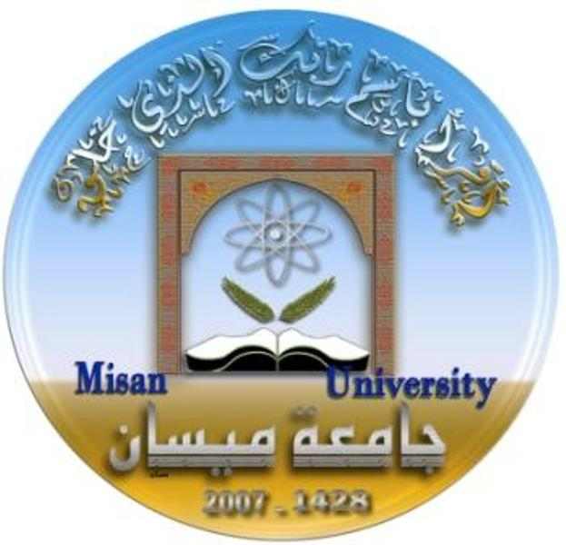

**Ministry of Higher Education**

**and Scientific Research**

**University of Misan**

**College of Science**

**Department of Biology**

**Studying Levels of Leptin, Resistin, Ovarian Hormones, Some Biochemical Parameters, and Oxidative Factors Associated with Different Trimesters of Pregnancy in Gestational Diabetic and Obese Women in Misan Province**

A Thesis

Submitted to the Council of the College of Science/University of Misan as Partial Fulfillment of the Requirements for the Master Degree in Biology

**By**

**Allaa Jamel Shhaeat**

**B.Sc. Biology (2005)**

**Supervised by**

**Prof. Dr. Ahmed Aboud Khalifa**

**December 2019 A. D** **Rabi Al-Thani 1441 A.H**