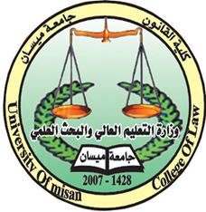**The Ministry of Higher Education and Scientific Research**

**University of Maysan**

**College of Law**

**The administration's obligation to Prevention**

**The Environmental Damages in Iraq**

**((A Comparative Study))**

**Thesis submitted To A**

**Council of College of Law - Misan University**

**Part of the requirements for a Master's Degree in Public Law as a**

**By Student**

**ZINAH SAMEER HASHIM**

**Supervisor By**

**PROF. Dr. Amer Zghair Mohaisen**

**1440 2018**