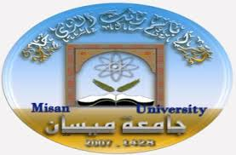

**Ministry of Higher Education and Scientific Research**

**University of Misan**

**College of Physical Education and Sports Sciences**

**Dietary-assisted ring training and effect on interleukin 6, free radicals guides and some physical abilities and offensive skills of young volleyball players**

**A letter you have submitted**

**Zahra Radhi Jabbar**

**To the Council of the Faculty of Physical Education and Sports Sciences - University of Maysan as part of the requirements for a master's degree in physical education and sports sciences**

**Supervised by**

**Dr. Majed Shendi Wali**

1438 e 2017 AD