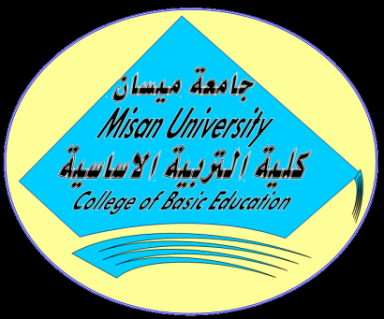

Ministry of Higher Education

And Scientific Research

University of Missan

College of Basic Education

Department of Elementary Schools/Graduate Studies

Topics and Categories of General Teaching

**The Knowledge of Mathematics Teachers of Realistic Evalution Its tools and Application Degree**

A Thesis Submitted to

The Council of Colleg of Basic Education / Missan University in partial Fulfilment of requiremeats for the degree of Master of Education

(Topics and Categories of General Teaching )

**Submitted By**

Hala Adnan khadim Al Saedi

**Supervised By**

Asst.prof.Rana Sabeeh Abood Asst.prof.Anwar Sabah Abdalmajed

**1439 AH 2018 AD**