Iraqi republic

Ministry of higher education and scientific research

Misan University

The Basic Education college

Graduate studies

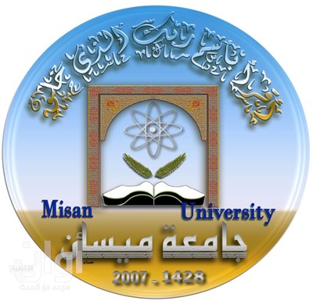

Evaluating the content of science textbook of the first grade intermediate in Iraq in the light of International trend standards TIMSS-2015 standards

A Thesis Submitted to the council of the college of Basic Education in partial fulfillment of the requirements for the degree of Master of Education in Curriculum and Methodology.

BY

RAGHAD WALEED TAHA ABU RAGEEF

Supervised by

Professor DR.AHMAD ABID ALMOHSIN

2019 A.D. 1441A.H.

Abstract

The present study aimed to evaluate the content of the first grade intermediate science book in Iraq in the light of the international standards of mathematics and science TIMSS-2015 by answering the following questions:

1. What TMSS-2015 standards should be met in the content of the first grade science textbook in Iraq?

2. What is the extent to which TIMSS-2015 standards are included in the biology topics of the first grade science textbook in Iraq?

3. To what extent are the TIMSS-2015 standards included in the physics topics of the first grade intermediate science textbook in Iraq?

4. To what extent are the TIMSS-2015 standards included in the chemistry topics of the first grade intermediate science textbook in Iraq?

5. What is the extent of the TIMSS-2015 standards included in the topics of Earth science for the first grade science textbook in Iraq?

6. What is the extent of the TIMSS-2015 standards included in the dimension of cognitive processes (knowledge, application and reasoning) in the first grade science textbook in Iraq?

The researcher used the method of analyzing the content. The researcher used two tools for the purpose of analysis and information gathering, the first is a post-content analysis tool and the second is a post-cognitive analysis tool .The two tools were built according to the list of TIMSS-2015 standards after making sure they are translated, certified and proven by the translators and arbitrators.

The content analysis tool included four sub-fields : biology, chemistry, physics, and earth sciences. Each field contains main criteria and sub-criteria, where the field of Biology includes (6) main criteria, (15) sub-criteria, while the field of Chemistry includes (3) Main criteria, which in turn include (9) sub-standards, and the field of Physics (5) main criteria, including (11) sub-criteria. As for the field of Geology, the main criteria reached (4) criteria, which included (9) sub-criteria, thus the content dimension of (117) sub-criteria, while the tool after cognitive processes included three sub-areas are knowledge, application and reasoning, and each field falls under a number of The main criteria, which totaled (16) main criteria, and each main criterion falls under a number of sub-criteria, which totaled (42) sub-criteria.

The research reached many results, the most important of which are:

The number of the main criteria achieved in the field of biology is (2) out of (6) main criteria and the main criterion (cells and their functions) came first among the main criteria by (15.29%), which is higher than the percentage set in the TIMSS standards. The main criterion (Life Cycles, Reproduction and Genetics) came second with an inclusion rate of 7.16%, higher than the TIMSS-2015 standards (4.86%). The TIMSS-2015 standards (6.80%), where the inclusion rate (0.97%), and the standard (human health) fell below the ratio TIMSS-2015 standards (3.88%), where the rate of inclusion (0.48%), which means there is no balance in the proportion of achievement of each of these criteria, while the content of science book for the first grade did not take into account the average (subject of biology) criteria Diversity, adaptation and natural selection) and (ecosystems) where the rate of inclusion is 0.0% each.

All the main standards have been achieved in the field of chemistry and the main criterion (composition of the material) came first among the main standards by (19.78%), which is five times higher than the rate set in the TIMSS-2015 standards by 4.54%. The main (chemical change) ranked second with an inclusion rate of 11.03%, which is twice that of the TIMSS-2015 standards (5.45%), while the material properties criterion is identical to that of the TIMSS-2015 standards (10%). Where the rate of inclusion in it (10.07%). The rates of inclusion of sub criteria in the field of chemistry were also variable and did not meet the standards set in the TIMSS-2015 criteria.

The number of the main criteria achieved in the field of physics is (3) out of (5) main criteria and the main criterion (physical conditions and changes in the material) came first among the main standards by (15.77%), which is more than the rate set in TIMSS-2015 Standards (4.54%). The main criterion (forces and movement) came in second place with a rate of inclusion (13.69%), which is higher than the rate set in the TIMSS-2015 standards (7.57%) and also the criterion (energy conversion and transfer) than the rate set in the TIMSS-2015 standards (3.78%) Where the rate of inclusion was 5.69%.

The degree of achievement of the TIMSS-2015 standards in the field of Earth science was achieved by an unrealized score of (0.0%).