**Mathematical model of the mechanoactivation process of modibden disulfide and carbon nanotubes**

А. Shchegolkov  
Department of Technology and Methods of Nanoproducts Manufacturing, Tambov State Technical University,Tambov, Russian Federation  
Energynano@yandex.ru

N. Zemtsova  
Department of Technology and Methods of Nanoproducts Manufacturing,  
Tambov State Technical University,Tambov, Russian Federation  
natasha_paramonova_68@mail.ruA.T.R Albairmani.

Department of Mechanics and Engineering Graphics

Tambov State Technical University,

Tambov, Russian Federation ali.eng9295@gmail.com

А. Shchegolkov  
Department of Technology and Methods of Nanoproducts Manufacturing  
Tambov State Technical University,Tambov, Russian Federation  
alexxx5000@mail.ru M.M. Al-Zahiwat,

Department of Petroleum Engineering, College of Engineering, University of Misan, Iraq chemical.eng85@gmail.com

***Abstract*** The proposed mathematical description of the mechanoactivation process of MoS2 and MWCNTs (multilayer carbon nanotubes)can be used to take into account the fundamental factors affecting the performance of both individual elements and the unit as a whole. This will improve the efficiency of MoS2 and MWCNTs distribution in various material objects with regard to their physical and mechanical properties. A description of the mechanoactivation unit is presented. The simulation takes into account possible effects related to the duration of the efficiency of the dispersed particles.

Keywords — mathematical model, carbon nanotubes, modibden disulfide, mechanoactivation.

Introduction

The joint use of carbon nanotubes and MoS2 has a wide range of applications and involves the creation of additives in engine oil [1], energy storage [2], as well as additives for polymers [3]. The authors of [1] conducted studies to determine the tribological characteristics of MoS2 using a four-ball tribotester. The coefficient of friction (COF) and the mean trace wear diameter (WSD) of antifriction additives were analyzed by tribological wear rate and trace wear studies on the worn surface of ball bearings.

To obtain a composite of MWCNTs (multi-layer carbon nanotubes) and MoS2 can be used a one-step process using chemical reagents [4].

Technological methods are known in which MoS2 is coated with MWCNTs [5] and the reverse situation when MWCNTs are coated with MoS2 [1].

In the process of synthesis of MoS2 nanoparticles, the shock jet technology can be used [6]. The possibility of controlling the structural and morphological properties of MoS2, which correlate with the physical and mechanical properties under different technological conditions is presented in [7]. The use of MoS2-based hybrid nanostructures obtained by wet chemical synthesis in a shock jet reactor improves the tribological and rheological properties of engine oil (10W-40) at any temperature [8].

Adaptation of the properties of disperse structures for various petroleum products can be achieved by using mechanoactivation technology, which allows increasing the activity of MWCNTs in the destruction of agglomerates. Mechanoactivation of MoS2 and MWCNTs is possible both in liquid - fuel or motor oil, and in a dry state followed by a stirring stage.

The processes of mechanical activation are accompanied by thermal releases, so it is necessary to study the temperature field distribution during mechanical activation of such materials as MoS2 and MWCNTs.

The purpose of this work is to develop a mathematical model of the mechanical activation of MoS2 and MWCNTs in motor oil.

# MATHEMATICAL MODEL

In order to increase the level of energy efficiency and reduce time costs, the most effective approach is to create a versatile and multifunctional equipment. In order to implement an effective process of mixing, mechanical activation and introduction of loose micro- and nano-dispersed materials into liquid motor oil - it is necessary to use such an approach in which simultaneous mechanical activation and accumulation of all materials is possible. To implement such an approach, the vortex layer apparatus (**VLA**), which has the ability to create a continuous process of mechanoactivation of MoS2 and MWCNTs with simultaneous introduction of these materials into the engine oil, shows high efficiency.

**VLA** works as follows (Fig. 1). The cooling system of inductors 4 (pipeline) and 5 (tank) is switched on, then their power supply and simultaneously supplying the processed product into the tube 1. Ferromagnetic particles 2 under influence of rotating electromagnetic field (caused by operation of inductors 3) perform intensive movement and process the product in the tube 1, causing in it the required physical and chemical transformations. The finished product is poured into the tank 6.

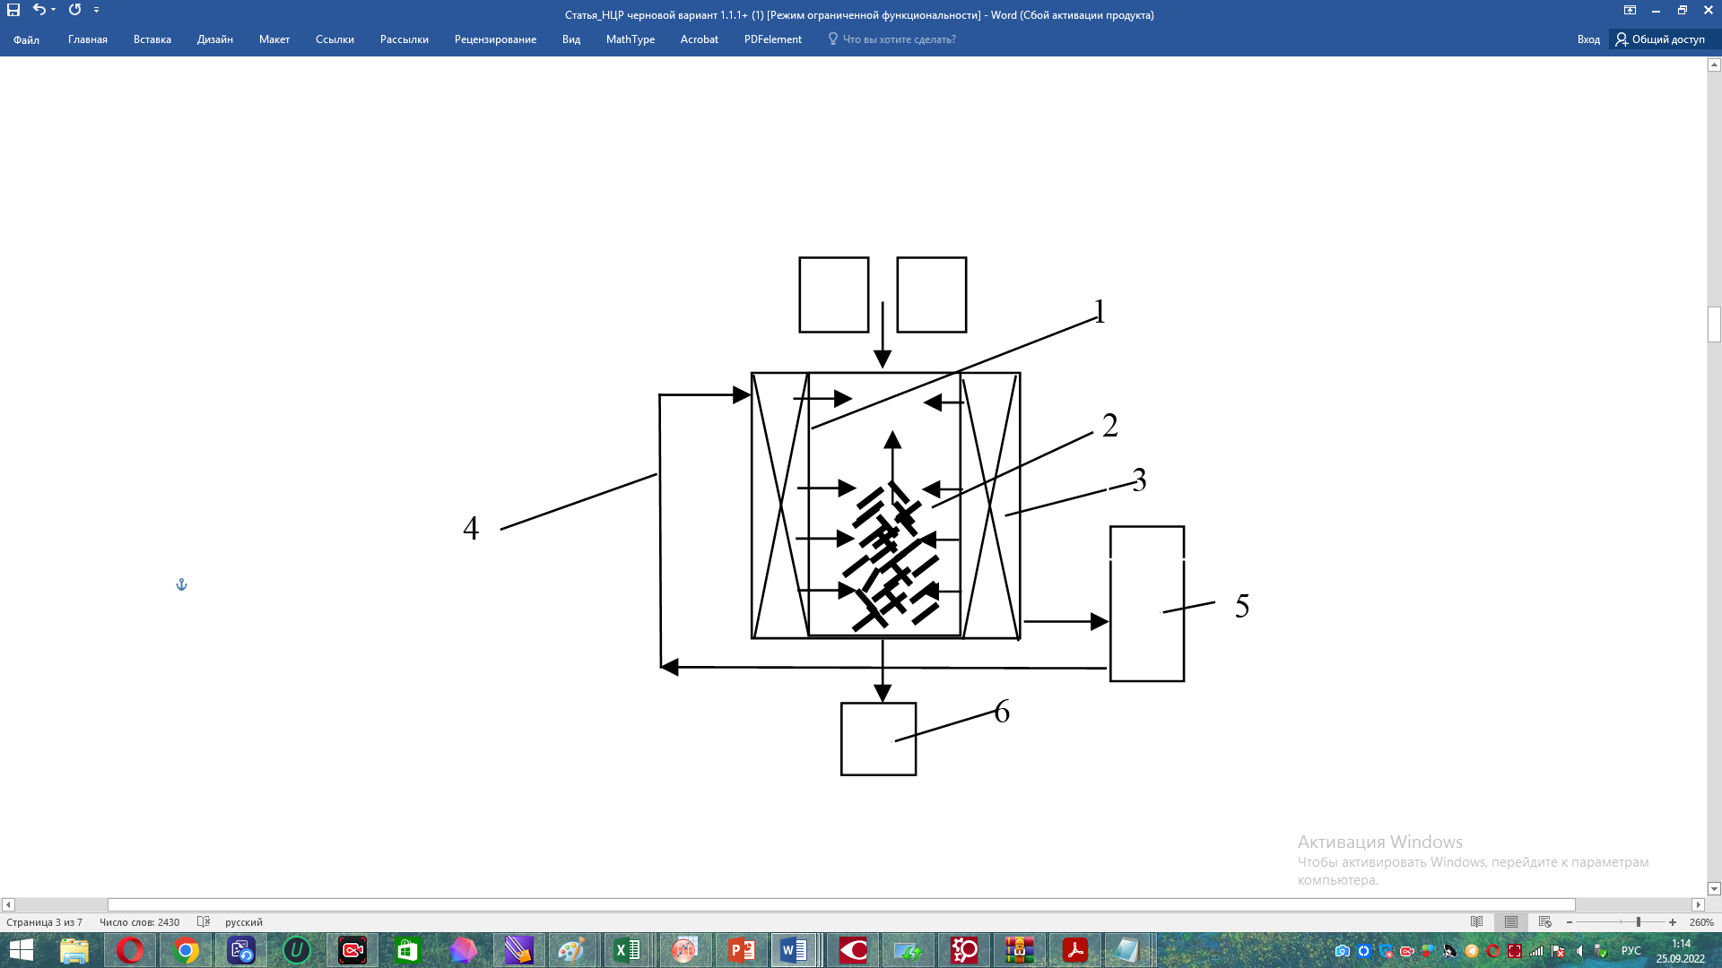

Fig. 1 **VLA** (vortex layer apparatus) with implicit pole inductor

Ferromagnetic particles - rods - are used as working bodies in the device, and there are certain empirical formulas for determining the necessary mass and configuration of them.

The **VLA** working zone is essentially a section of a tube in which a rotating (running) electromagnetic field is induced that affects the needles. The needles themselves become magnets (dipoles) and interact with the initial field, the original energy source. This results in a number of effects that, along with the mechanical and thermal effects of the needles, directly affect the substance, changing its physical and chemical properties.

Needles are the sources and driving force of almost all processes in the working zone of the ABC. They affect the substance in any medium: liquid, gas or vacuum. Moreover, the medium can be homogeneous or heterogeneous, and it itself influences the course of processes to a certain extent.

The paper shows that the motion of needles is mainly chaotic, which is formed by impact interactions of needles with each other, with solid particles (if any) and with the walls of the working area, creating in general a rotation about the axis. The rotational component of motion is given by the rotating electromagnetic field of the inductor (stator). Thus, a field is formed, called the vortex field, from which the apparatus was named - the vortex apparatus (**VLA**). The system of equations describing heat exchange in **VLA** is as follows:

|  |  |
| --- | --- |
|  | (1) |

where F1, F11, F2, - areas of grinding bodies, machine walls, dispersed material, m2;

P, Pa - heat effect arising from friction and collision of grinding bodies and from apparatus windings, W;

Tt.p., Ta, Tzh, Tsur - temperature of grinding bodies, **VLA**, fluid and environment, °С;

Ct.p., Ca, Cj - heat capacity of grinding bodies, **VLA**, liquid, J/(kg°С);

K1-2, K2-3, K1, - heat transfer coefficients from the grinding bodies to the liquid, from the liquid to the apparatus walls, from the walls of the device to the environment, W/(m2°С);

ρt.p., ρa, ρj - material densities of grinding bodies, apparatus and liquid, kg/m3;

ht.p., haa - heights of the inner chamber of the apparatus and grinding bodies, m;

Vzh - volume of liquid, m3;

τ - time, s.

The material balance for the dispersible system is as follows:

|  |  |
| --- | --- |
|  | (2) |

where *Mj* is the mass of fraction j of MoS2 and MWCNTs, kg; M is the total mass of MoS2 and MWCNTs, kg.

By dividing equation (2) by M, we obtain

|  |  |
| --- | --- |
|  | (3) |

where dimensionless values *fj* = *Mj/M* form the normalized particle size distribution.

The motion of grinding bodies in the vortex layer of **VLA** is described by the following equations:

|  |  |
| --- | --- |
|  | (4) |
|  | (5) |

where Fr, Fφ, M - constants characterizing the maximum value of forces and moments; K - coefficient of filling the working chamber with grinding bodies; n1, n2 - random functions, subject to the normal law of distribution; m - expectation of the radial component of the particle speed; φ - angle between the particle magnetic moment vector and magnetic field strength vector; r - distance from the inductor bore center; Kcr - total electromagnetic moment acting on grinding bodies, equal to their sum:

|  |  |
| --- | --- |
|  | (6) |

where *Ma*, *Mb*, *Mc* – phase torques *a*, *b*, *c*

For the rates of center formation and consumption during machining of MWNTs, and MoS2, an analytical record can be used to determine the formation of centers at a particular rate:

$ω=\frac{dN(τ)}{dτ}=n\frac{ds}{dτ},$ (7)

the rate of disappearance of active centers in the mechanically activated system:

$-\frac{dN\left(τ\right)}{dτ}=\frac{1}{τ_{0}}N\left(τ\right),$ (8)

the speed of interaction with gas molecules

$-\frac{dN\left(τ\right)}{dτ}=αkpN\left(τ\right).$ (9)

For expressions 7 - 9: N(τ) is the concentration of centers at time τ (centers/g); s is the specific surface of materials after fracture (mg2/g); n is the concentration of centers on new surfaces (centers/m2); p is gas pressure, kp is the collision frequency of gas molecules with active centers (s-1); α is the probability of chemical reaction during collision; constant (collision factor).

$k=\frac{ω}{\sqrt{2πmkT}},$ (10)

where ω is the collision cross section (~10-15cm-2), m is the mass of gas molecules, T is the temperature, k is the Boltzmann constant.

The change in the concentration of centers N(τ) is determined by the ratio of process velocities:

$\frac{dN(τ)}{dτ}=ω_{0}-\frac{1}{τ_{0}}N\left(τ\right)-αkpN\left(τ\right).$ (11)

During mechanoactivation of disperse material in **VLA**, the growth rate of its specific surface gradually decreases with time. If the duration of the process does not exceed a few minutes, the following statement takes place, which in analytical form is represented as follows:

$ω_{0}=n\frac{ds}{dτ}-const.$ (12)

Then by integrating expression (12) under the condition ω0 = const we have an analytical expression of the form:

$N\left(τ\right)=ω_{0}τ_{p}\left[1-exp\left(-\frac{τ}{τ_{p}}\right)\right]$

# Conclusion

The proposed mathematical description of the mechanoactivation process of MoS2 and MWCNTs can be used to take into account the fundamental factors affecting the performance of both individual elements and the unit as a whole. This will improve the efficiency of MoS2 and MWCNTs distribution in various material objects with regard to their physical and mechanical properties.

##### References

1. J. A. C. Cornelio, E. E. Blanco, J. L. Romero, J. S. Rudas, G. S. Guerrero, Al. Toro and L. M. Hoyos-Palacio, “Development of multiwalled carbon nanotubes (MWCNT's) functionalized with molybdenum disulfide (MoS2) by separate methodology”, Diam  Relat Mater,vol.122, 108814, 2022.
2. A. Schmidt, M. K. Ramos, C. M. Ferreira, B. A. Braz and Aldo J.G. Zarbin, “Molybdenum-based materials/carbon nanotubes nanocomposites prepared as thin and transparent films for aqueous K-ion batteries”, Electrochim. Acta, vol. 387, 138500, 2021.
3. D. Wang, X. Mu, W. Cai, X. Zhou, L. Song, C. Ma and Y. Hu, “Nano-bridge effects of carbon nanotubes on the properties reinforcement of two-dimensional molybdenum disulfide/polymer composites” , Compos. Part A Appl. Sci. Manuf., vol. 121, pp. 36-44, 2019.
4. Ke-J. Huang, L. Wang, Ji-Z. Zhang, L.-L. Wang and Y.-P. Mo, “One-step preparation of layered molybdenum disulfide/multi-walled carbon nanotube composites for enhanced performance supercapacitor”, Energy, vol. 67, pp. 234-240, 2014.
5. M. Ho Yang, S.-K. Hwang, J.-M. Jeong, Y. S. Huh and B. G. Choi, “Nitrogen-doped carbon-coated molybdenum disulfide nanosheets for high-performance supercapacitor”, Synth. Met., vol. 209, pp.528-533, 2015.
6. M. Wojtalik, Z. Bojarska and Ł. Makowski, “Experimental studies on the chemical wet synthesis for obtaining high-quality MoS2 nanoparticles using impinging jet reactor”, J Solid State Chem,vol. 285, p. 121254, 2020.
7. S. Kumar, T. Mishra and A. Mahata, “Manipulation of mechanical properties of monolayer molybdenum disulfide: Kirigami and hetero-structure based approach”, Mater. Chem. Phys., Vol. 252, p. 123280, 2020
8. Z. Bojarska, J. Kopytowski, M. Mazurkiewicz-Pawlicka, P. Bazarnik, S. Gierlotka, A. Rożeń and Ł. Makowski, “Molybdenum disulfide-based hybrid materials as new types of oil additives with enhanced tribological and rheological properties”, Tribol Int, vol. 160, p. 106999, 2021.