

**The Ministry of Education and Science of The Russian Federation Federal State Autonomous Educational Institution of Higher Professional Education**

**« The Ural Federal University named after the first President of Russia B. N. Yeltsin»**

**Institute of mathematics and computer science Department of Algebra and Discrete Mathematics**

# Statistic methods of programming as exemplified in the relation between the blood systolic pressure and the

**cholesterol level , age and other parameters in the central district of Al-Amarah city (Iraq)**

**Supervisor : Sergey V. Siziy Magister : Sami Atiyah Al-Farttoosi**

**Yekaterinburg 2015**

**Abstract** : We want to find the relation between systolic pressure of blood and some parameters such as cholesterol , age , work , salary , daily athletic , smoking cigarette , smoking hookah and diastolic pressure of blood .

We called the systolic pressure, fact, . We used linear trend for forecasting of the fact. We used data from January 2010 until December 2013 for calculation and data from January 2014 until August 2014 was used for verification of forecasting. We also used seasonal coefficients with linear trend and this gave us better result. Result was evaluated with root mean square error (RMSE). We used Microsoft Office Excel for computation. The last method of forecasting is functional method as:

*Y*  *A*1  *X*1(*t* **1)  *A*2  *X* 2 (*t* **2 )  ...  *A*8  *X*8 (*t* **8 )  *B*

We made a linear system and solution of this system gave us

*A*1, *A*2 ,..., *A*8 , *B* .

We used circular shift with correlation to calculate the lag between each independent variable 𝑋𝑖 and 𝑌 . The lag is 𝛼𝑖 for independent variable 𝑋𝑖 .

The result shows that functional method gives best result. In future work, we will consider more parameters such as geographical and weather parameters.

|  |  |  |
| --- | --- | --- |
| **RMSE for Linear Trend** | **RMSE for Linear trend with Seasonal Coefficients** | **RMSE for Functional Method** |
| **16.5265249** | **13.61124031** | **11.548174** |

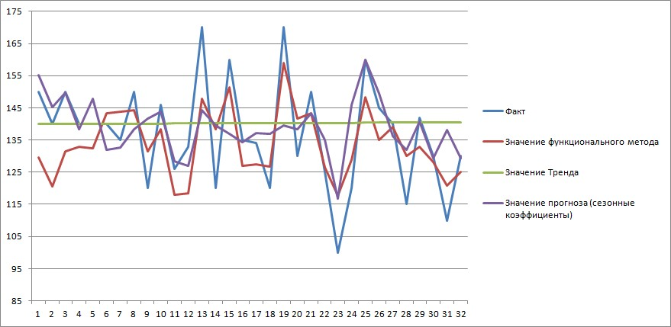

Fact

Functional Method

Seasonal coeff

Linear trend